CSS BRITISH HISTORY · TOPIC 8 · KNOWLEDGE BASE
The Second World War, Attlee, the Cold War and the End of Empire (1939–1979)
Britain's finest hour and its long retreat — the Second World War, Churchill, the war conferences and the United Nations, the Attlee welfare state, the Cold War and NATO, the Commonwealth, decolonisation, India, Palestine and Suez, home affairs and the EEC to 1979, with the story carried on to 2026

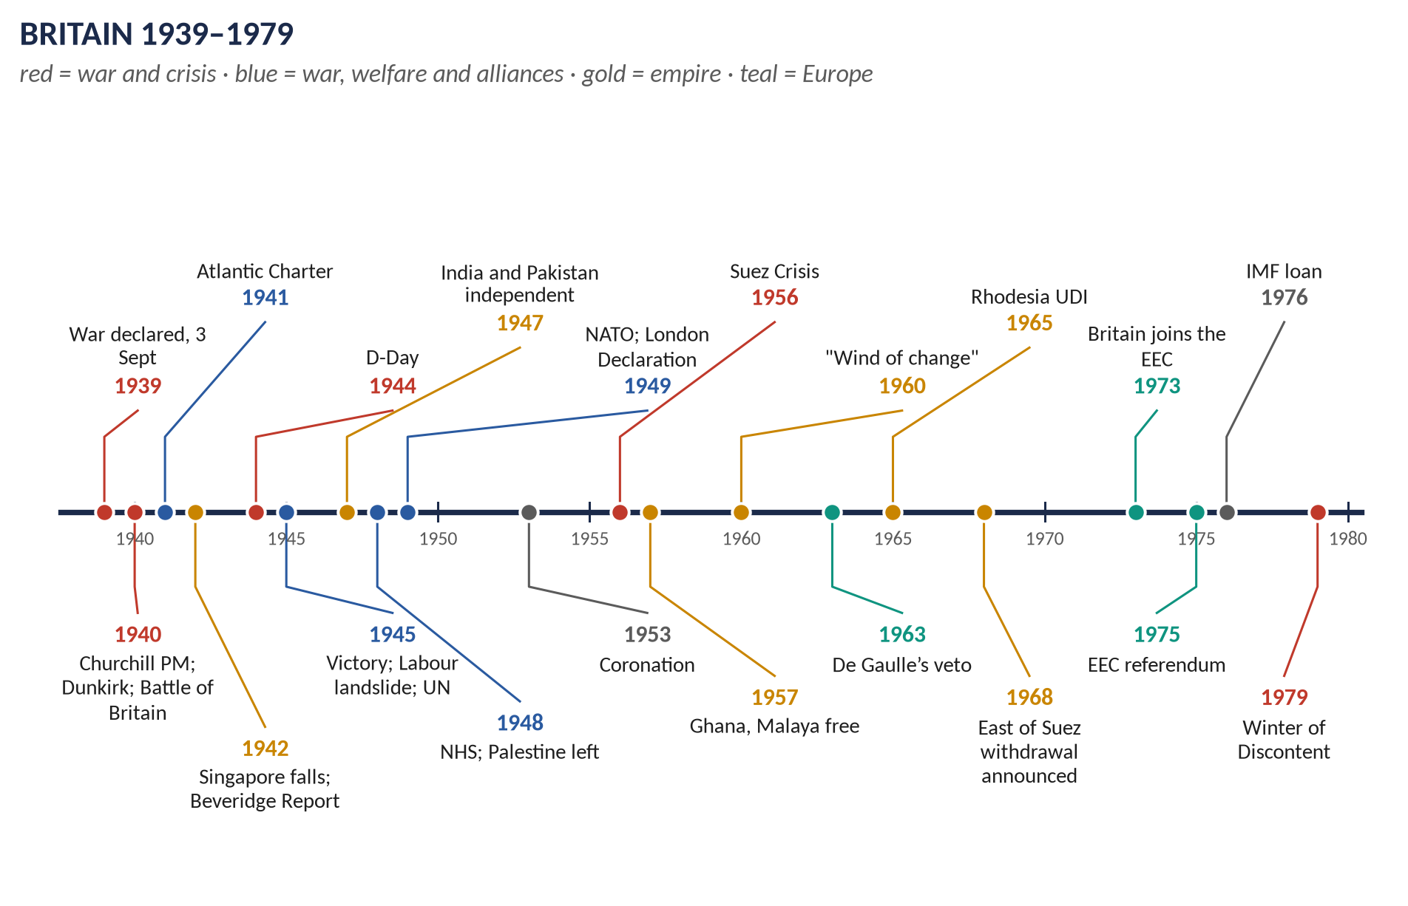
Syllabus heads XII and XIII. The largest topic of all: 14 past items in 2015–2026 — the Commonwealth 3, decolonisation and India 3, Suez and the Middle East 2, Churchill 2, the Second World War 2, Attlee, and Britain and the USA — and 10 MCQs. Told from zero, then eleven chapters covering both heads in full, with 120 one-liners and a stand-alone revision sheet.
Topic 8 of 10 · read with the companion document T8QA
Contents
HOW TO USE THIS · Updating the contents
Right-click the contents → Update Field → Update entire table, before saving as PDF.

How to Use This Document 7
What this Topic covers 7
Part Zero — The ABC Before the Story 8
0.1 Britain in 1939 — the simple picture 8
0.2 Britain in 1979 — the other end 8
0.3 The words you need 8
Part One — The Story 10
1.1 Britain alone (1939–1941) 10
1.2 The Grand Alliance (1941–1945) 10
1.3 The people's peace (1945–1951) 10
1.4 The Cold War (1946–1979) 10
1.5 The end of empire (1947–1980) 11
1.6 Home and Europe (1951–1979) 11
Part Two — The Cast and the Time-line 12
2.1 The cast 12
2.2 The time-line 13
Part Three — The Chapters 14
Chapter 1 · The Second World War, 1939–1945 15
1.1 The causes 15
1.2 The course of the war — Britain's story 16
(i) 1939–1940: the Phoney War and the fall of the West 16
(ii) 1940–1941: Britain alone 17
(iii) 1941–1942: a world war 17
(iv) 1942–1945: the tide turns 17
1.3 The home front 18
1.4 The cost 18
Chapter 2 · Winston Churchill (1874–1965) 19
2.1 His life at a glance 19
2.2 Churchill the warrior 20
(i) The young soldier 20
(ii) Director of war (1911–15) 20
(iii) The war leader (1940–45) 20
(iv) Criticisms 21
2.3 Churchill the statesman 21
(i) Before 1940 21
(ii) War statesman 21
(iii) Post-war statesman 21
2.4 Churchill the man of letters 21
2.5 Assessment 22
Chapter 3 · The War Conferences and the United Nations 23
3.1 The great conferences 23
3.2 The Atlantic Charter (14 August 1941) 23
3.3 The creation of the United Nations 24
Structure 24
How it differed from the League 24
Chapter 4 · The Effects of the Second World War on Britain 25
4.1 Economic effects 25
4.2 Social effects 25
4.3 Political effects 25
4.4 International and imperial effects 25
Chapter 5 · The Attlee Government, 1945–1951 27
5.1 The team 27
5.2 The problems in 1945 27
(i) Economic 27
(ii) Social — Beveridge's "Five Giants" 27
5.3 The social reforms — defeating the Five Giants 28
5.4 The economic measures 28
(i) Nationalisation — the "mixed economy" 28
(ii) Money and trade 28
5.5 The economic crises 29
5.6 Other achievements 29
5.7 Assessment — how successful? 29
Chapter 6 · Britain in the Cold War: NATO and the Special Relationship 31
6.1 How the Cold War began 31
6.2 Bevin and the making of NATO 31
6.3 Britain's Cold War commitments 31
6.4 The special relationship 32
6.5 Subservient to the USA? — the long view (1945–2026) 32
(i) Why some believe Britain was subservient 32
(ii) Evidence of independence 33
(iii) Explaining the pattern 33
Chapter 7 · The Commonwealth 34
7.1 What is the Commonwealth? 34
7.2 The development of the idea — stage by stage 34
Stage 1 · Self-government for the settler colonies (1839–1914) 34
Stage 2 · From Dominions to equals (1914–1931) 35
Stage 3 · The modern, multiracial Commonwealth (1947–1965) 35
Stage 4 · A community of values (1971–2026) 35
7.3 How the Commonwealth differs from the Empire 36
7.4 The significance of the Commonwealth 36
Chapter 8 · Decolonisation 37
8.1 What decolonisation means 37
8.2 The motives — why Britain decolonised 38
(i) Economic weakness 38
(ii) Nationalism 38
(iii) The Second World War 38
(iv) International pressure 38
(v) The Cold War 39
(vi) British decisions and attitudes 39
(vii) The Commonwealth as a bridge 39
8.3 India, 1947 39
(i) Why Britain left 39
(ii) How Britain left 40
(iii) The consequences 40
8.4 Other major cases 40
(i) Malaya (1948–1957) 40
(ii) The Gold Coast → Ghana (1957) 41
(iii) Kenya (1952–1963) 41
(iv) The wind of change (1960–1966) 41
(v) Aden (1967) 41
(vi) Rhodesia (1965–1980) 41
(vii) Hong Kong (1997) 41
8.5 Global pressures or British decisions? — weighing the causes 41
Chapter 9 · The Middle East, Palestine and Suez 43
9.1 Britain in the Middle East 43
9.2 Palestine (1917–1948) 43
(i) The problem Britain created 43
(ii) The inter-war conflict 44
(iii) Why Britain withdrew (1945–1948) 44
9.3 Other crises of influence 44
9.4 The Suez Crisis (1956) 45
(i) The background 45
(ii) The crisis 45
(iii) Why Britain withdrew from Suez 45
(iv) Consequences 46
Chapter 10 · Home and Europe, 1951–1979 47
10.1 The Conservative years (1951–1964) 47
10.2 The Wilson years (1964–1970) 47
10.3 Heath (1970–1974) 47
10.4 Wilson and Callaghan (1974–1979) 47
10.5 Britain and the EEC 48
Chapter 11 · The Legacy — to 2026 49
Part Four — Historians and Quotations 50
Part Five — The Examiner's Record 51
Part Six — The One-Liner Bank 53
One-liners · The Second World War 53
One-liners · Churchill 54
One-liners · The conferences and the UN 54
One-liners · Attlee 55
One-liners · The Cold War and the USA 55
One-liners · The Commonwealth 56
One-liners · Decolonisation, India and Suez 56
Part Seven — Revision Sheet · Topic 8: The Second World War, Attlee, the Cold War and the End of Empire 58
R8.1 The Second World War 58
R8.2 Churchill 58
R8.3 Conferences and the UN 58
R8.4 Attlee 1945–51 59
R8.5 The Cold War and the USA 59
R8.6 The Commonwealth 59
R8.7 Decolonisation and India 59
R8.8 Palestine and Suez 60
R8.9 Home and Europe 1951–79 60

How to Use This Document

What this Topic covers
Topic 8 covers the forty years from 1939 to 1979. It takes in syllabus Head XII (Britain and the Second World War: causes and events; Churchill and the war conferences; the creation of the United Nations; the effects of the war; the reforms of the Labour government) and Head XIII (Britain and the Cold War: the creation of the Commonwealth; NATO; decolonisation; internal policies and the EEC; foreign policy).
WHAT THE EXAMINER HAS ASKED · Why this topic matters
14 items in 2015–2026 and 10 MCQs — more than any other topic. The favourites: the Commonwealth (2015, 2017, 2024 sn), decolonisation (2019 with India, 2024, 2026), the Middle East and Suez (2020, 2022 sn), Churchill (2018 sn, 2022), the Second World War (2016 sn, 2023), Attlee (2019) and Britain's relationship with the USA (2018). Every one is answered in T8QA; this Knowledge Base also covers the parts not yet asked — the war conferences and the UN, NATO, home policy 1951–79 and the EEC.

THE STORY IN SIMPLE WORDS · Where this topic fits in the story
Topic 7 ended with Britain declaring war on Germany on 3 September 1939. Topic 8 tells how Britain survived and won that war under Churchill, built a welfare state under Attlee, joined the USA in the Cold War, gave up almost all its empire, and turned towards Europe. Topic 9 continues from Margaret Thatcher (1979).

Part Zero — The ABC Before the Story

0.1 Britain in 1939 — the simple picture
- A great power, but a tired one: the largest empire in history (about a quarter of the world's people), a strong navy, but an economy weakened by the First World War and the Depression.
- Government: the National Government under Neville Chamberlain, mainly Conservative.
- The enemy: Nazi Germany under Adolf Hitler, allied with Fascist Italy (Mussolini) and, from 1940, Japan — together, the Axis.
- The allies: at first only France, the Dominions (Canada, Australia, New Zealand, South Africa) and the colonies, above all India.

0.2 Britain in 1979 — the other end
- The empire had gone: only a few small territories (Hong Kong, Gibraltar, the Falklands) remained.
- A welfare state: the NHS, pensions, benefits, council housing.
- A member of the European Economic Community (since 1973).
- A junior partner of the USA in NATO and the Cold War; a nuclear power.
- An economy in trouble: inflation, strikes, the IMF loan (1976), the "Winter of Discontent" (1978–79).

0.3 The words you need
Word | What it means, simply
Axis / Allies | Germany, Italy and Japan / Britain, the Commonwealth, the USSR, the USA and others.
Blitzkrieg | "Lightning war": fast attacks with tanks and aircraft.
The Blitz | The German bombing of British cities, 1940–41.
Grand Alliance | Britain, the USSR and the USA together against Hitler (from 1941).
United Nations (UN) | The world organisation founded in 1945 to keep peace — the League's successor.
Welfare state | A state that protects all citizens against poverty, sickness and unemployment "from the cradle to the grave".
Nationalisation | The state taking over an industry (coal, railways) from private owners.
Cold War | The rivalry (1947–1991) between the USA with its allies and the USSR with its allies — without direct war between them.
Iron Curtain | The line dividing communist Eastern Europe from the West (Churchill, 1946).
NATO | The North Atlantic Treaty Organisation (1949): a defence alliance of the USA, Canada, Britain and Western Europe.
Special relationship | The close alliance between Britain and the USA (Churchill's phrase, 1946).
Decolonisation | The process by which colonies became independent states.
Dominion | A self-governing former colony, such as Canada or Australia.
Commonwealth | The voluntary association of independent states, mostly former British territories.
Mandate | A territory (e.g. Palestine) run by Britain on behalf of the League of Nations.
Partition | Dividing a country into separate states (India and Pakistan, 1947).
EEC | The European Economic Community (1957) — the "Common Market", ancestor of the European Union.
Consensus | The broad agreement of the main parties (1945–79) on the welfare state, full employment and a mixed economy.

KEY IDEA · The one idea to hold on to
Britain won the Second World War but was exhausted by it. For the next forty years it built a welfare state at home while it lost an empire abroad, and searched for a new role — as America's closest ally, as head of the Commonwealth, and finally as a member of Europe. As the US statesman Dean Acheson said in 1962: "Great Britain has lost an empire and has not yet found a role."

Part One — The Story
THE STORY IN SIMPLE WORDS · The story in simple words
Read this Part first, straight through. Every event is explained in detail in the chapters.

1.1 Britain alone (1939–1941)
After Germany invaded Poland, Britain declared war on 3 September 1939. Nothing much happened in the West for months — the "Phoney War". Then in April–May 1940 Hitler overran Norway, Denmark, the Netherlands, Belgium and France. Winston Churchill became Prime Minister on 10 May 1940. The British army was trapped at Dunkirk and rescued by a fleet of warships and little boats (Operation Dynamo). France surrendered in June. Britain stood alone. In the Battle of Britain (summer 1940) the RAF defeated the German air force and Hitler's invasion was called off. German bombers then attacked British cities night after night — the Blitz (1940–41).

1.2 The Grand Alliance (1941–1945)
In June 1941 Hitler invaded the Soviet Union; in December 1941 Japan attacked the Americans at Pearl Harbor, and the USA entered the war. Britain now had powerful allies. Japan conquered Malaya and Singapore (February 1942) — a humiliating British defeat. But in late 1942 the tide turned: the British won at El Alamein in Egypt, the Soviets at Stalingrad, the Americans at Midway. On 6 June 1944 — D-Day — Allied armies landed in Normandy. Germany surrendered on 8 May 1945 (VE Day). After atomic bombs fell on Hiroshima and Nagasaki, Japan surrendered in August 1945.

1.3 The people's peace (1945–1951)
In July 1945 the voters threw out Churchill and elected Labour under Clement Attlee with a huge majority. Following the Beveridge Report (1942), Labour built the welfare state — above all the National Health Service (1948) — and took coal, railways and other industries into public ownership. But Britain was nearly bankrupt; it borrowed from America and lived through years of austerity and rationing.

1.4 The Cold War (1946–1979)
The wartime alliance with the Soviet Union broke down. In 1946 Churchill warned that an "Iron Curtain" had fallen across Europe. Britain helped create NATO (1949), built its own atomic bomb (1952), fought in Korea (1950–53), and became America's closest ally — the "special relationship".

1.5 The end of empire (1947–1980)
Britain began to give up its empire. India and Pakistan became independent in August 1947, Burma and Ceylon in 1948; Britain left Palestine in 1948. In 1956 Britain and France invaded Egypt to regain the Suez Canal, but the USA forced them to withdraw — a turning point. Prime Minister Harold Macmillan spoke of a "wind of change" in Africa (1960); within a few years almost all the African colonies were free. The former colonies joined a new, free Commonwealth.

1.6 Home and Europe (1951–1979)
The Conservatives governed from 1951 to 1964: rationing ended, and Macmillan said people had "never had it so good". The 1960s brought "Swinging London". Britain was twice refused entry to the EEC by France's de Gaulle (1963, 1967) and finally joined in 1973. The 1970s were troubled: strikes, a three-day week (1974), high inflation, an emergency loan from the IMF (1976) and the strikes of the "Winter of Discontent" (1978–79), which brought Margaret Thatcher to power in May 1979.
VERDICT · The story in one sentence
Between 1939 and 1979 Britain fought and won a world war under Churchill, built a welfare state under Attlee, became America's chief ally in the Cold War, peacefully (mostly) gave up the largest empire in history in favour of a free Commonwealth, and at last joined Europe — while struggling with economic decline.

Part Two — The Cast and the Time-line

2.1 The cast
Person | Dates / office | Who they were — in one line
Winston Churchill | PM 1940–45, 1951–55 | War leader; statesman; Nobel Prize for Literature (1953).
Clement Attlee | PM 1945–51 | Labour leader who built the welfare state and freed India.
Ernest Bevin | Foreign Sec. 1945–51 | Labour's Foreign Secretary; a founder of NATO.
Aneurin Bevan | Health Minister 1945–51 | Created the NHS.
Sir Stafford Cripps | Chancellor 1947–50 | "Austerity"; the Cripps Mission to India (1942).
William Beveridge | 1879–1963 | His Report (1942) planned the welfare state.
Franklin D. Roosevelt | US President 1933–45 | Churchill's partner; Lend-Lease; Atlantic Charter.
Joseph Stalin | Soviet leader 1924–53 | Wartime ally; Cold War enemy.
Harry Truman | US President 1945–53 | Truman Doctrine; Marshall Plan; NATO.
Anthony Eden | PM 1955–57 | Resigned after Suez.
Harold Macmillan | PM 1957–63 | "Never had it so good"; "wind of change"; first EEC application.
Iain Macleod | Colonial Sec. 1959–61 | Sped up African independence.
Harold Wilson | PM 1964–70, 1974–76 | Devaluation; East of Suez withdrawal; the 1975 referendum.
Edward Heath | PM 1970–74 | Took Britain into the EEC (1973).
James Callaghan | PM 1976–79 | IMF loan; Winter of Discontent.
Mahatma Gandhi | 1869–1948 | Leader of Indian non-violent nationalism.
Jawaharlal Nehru | 1889–1964 | Congress leader; India's first PM.
Muhammad Ali Jinnah | 1876–1948 | Leader of the Muslim League; founder of Pakistan.
Lord Mountbatten | Viceroy 1947 | The last Viceroy of India.
Gamal Abdel Nasser | Egypt 1954–70 | Nationalised the Suez Canal (1956).
Charles de Gaulle | France 1958–69 | Vetoed Britain's EEC entry twice.
Elizabeth II | Queen 1952–2022 | Crowned 2 June 1953; Head of the Commonwealth for 70 years.

2.2 The time-line
Figure 1 · Britain 1939–1979.

Part Three — The Chapters

Chapter 1 · The Second World War, 1939–1945

1.1 The causes
Cause | Explanation
The Treaty of Versailles (1919) | Germany resented the war guilt clause, reparations, lost lands and disarmament; Hitler promised to destroy the treaty.
The Great Depression (1929–33) | Mass unemployment in Germany helped the Nazis to power (January 1933); in Japan it strengthened the militarists.
Hitler's aims | To overturn Versailles, unite all Germans, and win Lebensraum ("living space") in the East — ideas set out in Mein Kampf (1925).
The failure of the League | Manchuria (1931) and Abyssinia (1935) showed aggression paid (Topic 7).
Appeasement | Britain and France gave way over the Rhineland (1936), Austria (1938) and the Sudetenland (Munich, 1938), encouraging Hitler.
The Nazi–Soviet Pact (23 August 1939) | Hitler and Stalin agreed not to fight each other and secretly to divide Poland — Hitler could attack Poland without fearing a two-front war.
The invasion of Poland (1 September 1939) | Britain and France had guaranteed Poland (March 1939); they declared war on 3 September.

KEY IDEA · The historians
A. J. P. Taylor (1961) saw Hitler as an opportunist and blamed the Western powers' mistakes; most historians (e.g. Alan Bullock, Richard Overy) see Hitler's long-term aims of expansion and racial war as the central cause.

1.2 The course of the war — Britain's story
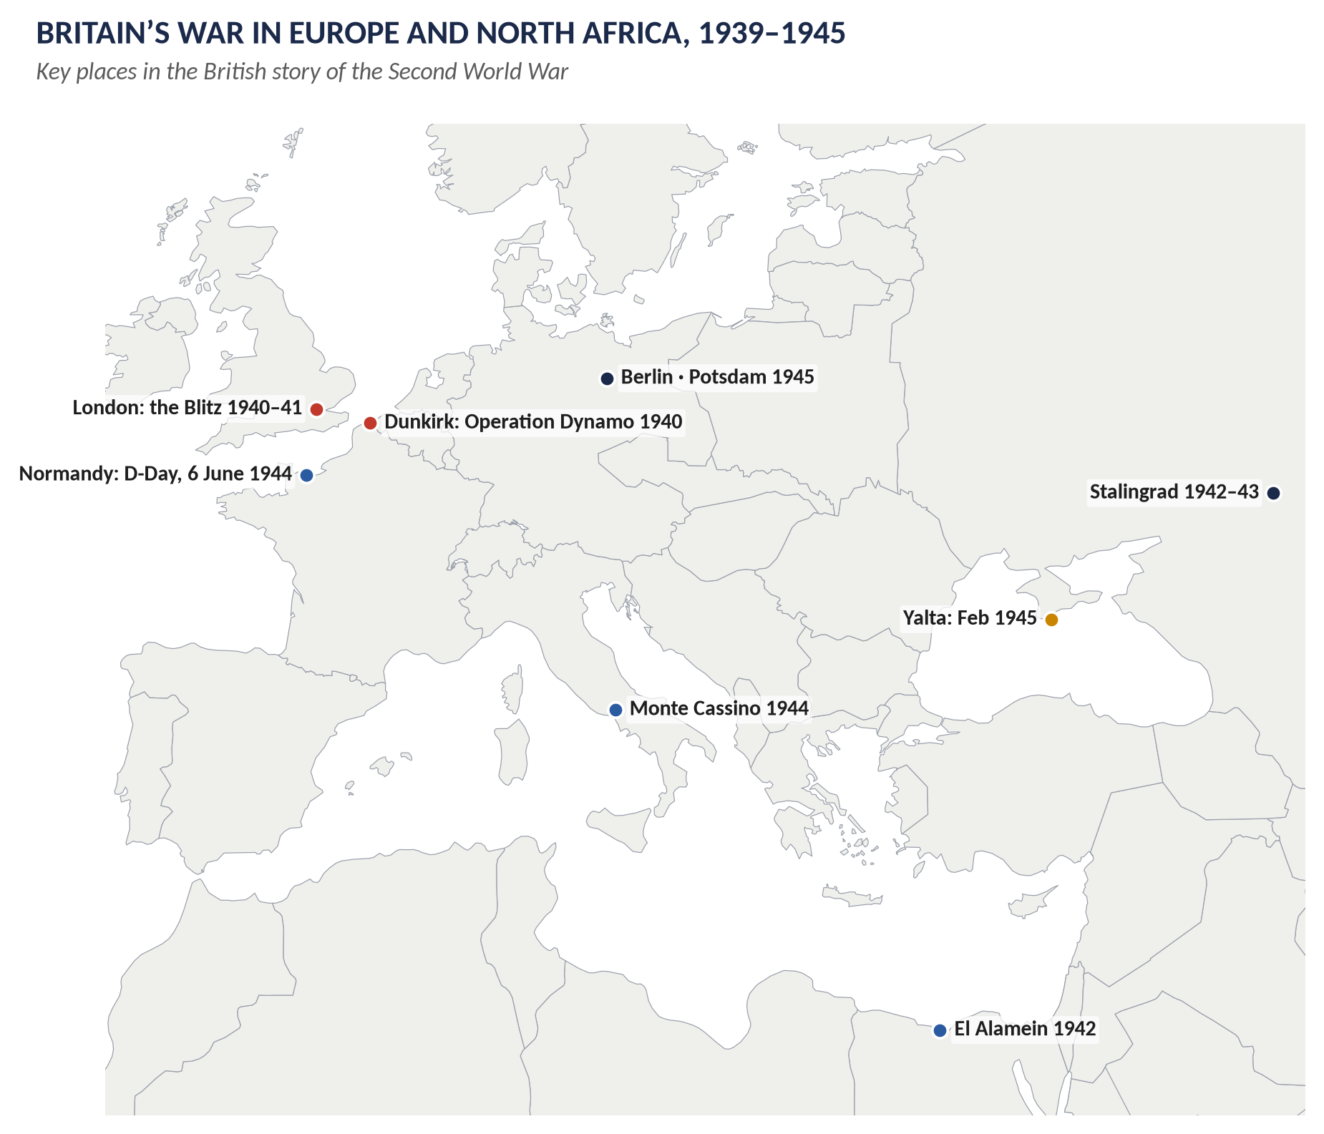
Figure 2 · Britain's war in Europe and North Africa.

(i) 1939–1940: the Phoney War and the fall of the West
- September 1939 – April 1940: the "Phoney War" — little fighting in the West; Poland was conquered in weeks.
- April 1940: Germany invaded Denmark and Norway; the British campaign in Norway failed.
- 7–8 May 1940: the Norway debate in the Commons; Leo Amery quoted Cromwell to Chamberlain: "In the name of God, go!"
- 10 May 1940: Germany attacked the Netherlands, Belgium and France; Churchill became Prime Minister of a coalition government (with Labour).
- 13 May: Churchill: "I have nothing to offer but blood, toil, tears and sweat."
- 26 May – 4 June 1940: Operation Dynamo — the evacuation from Dunkirk of about 338,000 British and French soldiers, using warships and hundreds of "little ships". Churchill: "We shall fight on the beaches … we shall never surrender" (4 June).
- 22 June 1940: France surrendered. Churchill: "Let us … so bear ourselves that … men will still say, This was their finest hour" (18 June).

(ii) 1940–1941: Britain alone
- The Battle of Britain (July–October 1940): the German air force (Luftwaffe) tried to destroy the RAF to prepare an invasion (Operation Sea Lion). The RAF's Spitfires and Hurricanes, guided by radar, won. Churchill: "Never in the field of human conflict was so much owed by so many to so few" (20 August). 15 September is "Battle of Britain Day". Hitler postponed the invasion.
- The Blitz (September 1940 – May 1941): night bombing of London, Coventry (November 1940), Liverpool, Birmingham, Glasgow and other cities; about 43,000 civilians killed.
- The Battle of the Atlantic (1939–45): German U-boats attacked the ships bringing food and arms; convoys, radar, air cover and the breaking of the Enigma code at Bletchley Park won it by 1943.
- Lend-Lease (March 1941): the USA supplied Britain with arms, to be paid for later.
- North Africa and the Mediterranean: victories over Italy (1940–41), then defeats by Rommel's Afrika Korps; Greece and Crete lost (1941).

(iii) 1941–1942: a world war
- 22 June 1941: Operation Barbarossa — Germany invaded the USSR. Churchill at once offered help: "If Hitler invaded Hell I would make at least a favourable reference to the devil in the House of Commons."
- August 1941: the Atlantic Charter (Chapter 3).
- 7 December 1941: Japan attacked Pearl Harbor; the USA entered the war. Churchill: "So we had won after all!"
- 15 February 1942: Singapore surrendered to Japan — about 80,000 British, Indian and Australian troops captured; Churchill called it "the worst disaster and largest capitulation in British history". Burma was lost; India was threatened.

(iv) 1942–1945: the tide turns
- El Alamein (23 October – 4 November 1942): General Montgomery's Eighth Army defeated Rommel. Churchill: "Before Alamein we never had a victory. After Alamein we never had a defeat." The Axis were cleared from North Africa (May 1943).
- Stalingrad (1942–43): the great Soviet victory.
- Italy (1943–45): the invasion of Sicily (July 1943) and Italy; Mussolini fell; slow fighting (Monte Cassino, 1944).
- The bombing of Germany: RAF Bomber Command under Arthur Harris — Hamburg (1943), Dresden (February 1945) — about 55,000 aircrew killed; still debated.
- D-Day (6 June 1944): Operation Overlord — British, American and Canadian forces landed on five Normandy beaches (about 156,000 men on the first day); Paris freed (August 1944).
- Burma: General Slim's "Forgotten Army" defeated the Japanese at Imphal and Kohima (1944) and retook Burma (1945).
- Victory in Europe: Hitler killed himself on 30 April 1945; Germany surrendered — VE Day, 8 May 1945.
- Victory over Japan: atomic bombs on Hiroshima (6 August) and Nagasaki (9 August); Japan surrendered (15 August, VJ Day; signed 2 September 1945).

1.3 The home front
- Evacuation: about 1.5 million children, mothers and others moved from cities to the countryside in the first days (September 1939) — middle-class Britain discovered the poverty of city children.
- Rationing: from January 1940 (bacon, butter, sugar), extended to meat, tea, clothes; "Dig for Victory".
- Total mobilisation: Ernest Bevin, Minister of Labour, directed workers; conscription of women (December 1941) — the first country to do so; by 1943 most single women aged 19–40 were in the forces, industry or civil defence.
- Civil defence: the ARP (air raid wardens), the Home Guard, the Auxiliary Fire Service.
- Planning for peace: the Beveridge Report (December 1942); the Butler Education Act (1944); the white paper on full employment (1944).
- "The people's war": shared danger and fair shares created a sense of national unity and a demand for a better Britain after the war.

1.4 The cost
- British deaths: about 384,000 servicemen and about 67,000 civilians — about 450,000 in all (fewer than in 1914–18).
- World deaths: about 70–85 million, including 6 million Jews murdered in the Holocaust.
- Britain's economy: see Chapter 4.
WHAT THE EXAMINER HAS ASKED · Where Chapter 1 has been asked
2023 Q6 (causes, major developments and aftermath) · 2016 Q8(a) (short note: the Second World War). MCQs 2025: the Dunkirk evacuation was Operation Dynamo; the German bombing campaign was the Blitz.

Chapter 2 · Winston Churchill (1874–1965)
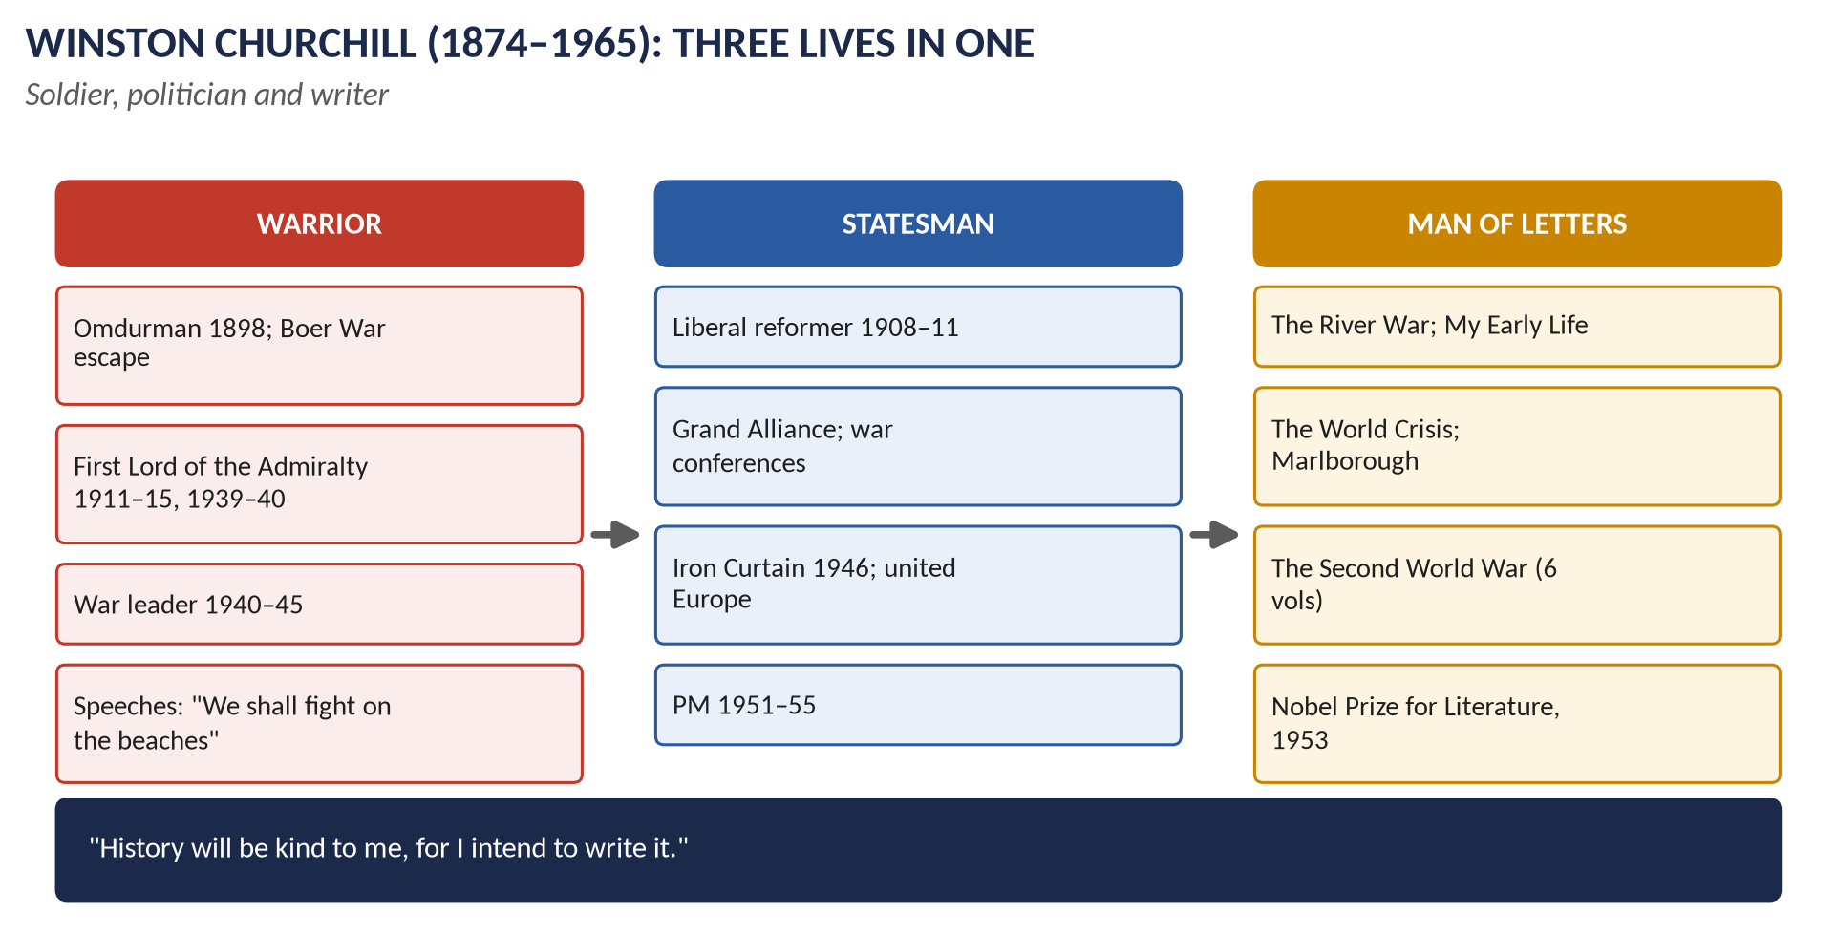
Figure 3 · Churchill: soldier, statesman, writer.

2.1 His life at a glance
Years | Event
1874 | Born at Blenheim Palace, son of Lord Randolph Churchill and the American Jennie Jerome.
1893–95 | Harrow; Sandhurst military college; the 4th Hussars.
1895–1900 | Soldier and war correspondent: Cuba (1895), the North-West Frontier of India (1897), the Sudan — he rode in the cavalry charge at Omdurman (1898) — and the Boer War, where he was captured and escaped (1899), becoming a national hero.
1900 | Conservative MP for Oldham.
1904 | Crossed the floor to the Liberals over free trade.
1908–10 | President of the Board of Trade: labour exchanges, trade boards.
1910–11 | Home Secretary: Tonypandy; the siege of Sidney Street; prison reform.
1911–15 | First Lord of the Admiralty: prepared the navy for war; the failed Gallipoli campaign (1915) cost him his post.
1916 | Served as a battalion commander on the Western Front.
1917–22 | Minister of Munitions (1917); War and Air (1919–21); Colonial Secretary (1921–22) — the Irish Treaty, the Middle East settlement.
1924 | Rejoined the Conservatives: "Anyone can rat, but it takes a certain ingenuity to re-rat."
1924–29 | Chancellor of the Exchequer: returned to the gold standard (1925) — later he called it the biggest mistake of his life; the British Gazette in the General Strike.
1929–39 | The "wilderness years": out of office; opposed Indian self-government; supported Edward VIII (1936); warned constantly against Hitler and demanded rearmament; condemned Munich.
1939–40 | First Lord of the Admiralty again ("Winston is back").
1940–45 | Prime Minister of the wartime coalition.
1945 | Defeated in the general election.
1946 | The "Iron Curtain" speech at Fulton, Missouri (5 March); the Zurich speech calling for a "United States of Europe" (September).
1951–55 | Prime Minister again.
1953 | Knighted (Garter); Nobel Prize for Literature.
1965 | Died on 24 January; state funeral.

2.2 Churchill the warrior

(i) The young soldier
A brave, adventurous cavalry officer who deliberately sought danger and fame: Cuba, the North-West Frontier, Omdurman (1898) and the Boer War (capture and escape, 1899). In 1916 he commanded the 6th Royal Scots Fusiliers in the trenches.

(ii) Director of war (1911–15)
As First Lord of the Admiralty he modernised the navy (oil-fired ships, the naval air service, early work on the tank) and had the fleet ready in 1914. But the Dardanelles/Gallipoli campaign (1915) — his plan to knock Turkey out of the war — ended in disaster, and he was dismissed.

(iii) The war leader (1940–45)
1. Defiance: in May 1940, when some ministers (Halifax) wanted to explore peace terms through Mussolini, Churchill insisted on fighting on.
2. Inspiration: his speeches and broadcasts — "blood, toil, tears and sweat", "we shall fight on the beaches", "their finest hour", "the few" — gave the nation courage. As Ed Murrow said, "he mobilised the English language and sent it into battle".
3. Energy and control: he was also Minister of Defence, drove the service chiefs hard, visited bombed cities and the front, and read Enigma intelligence ("Action this day").
4. Strategy: he defended the Middle East and Mediterranean (Alamein, North Africa, Italy — "the soft underbelly of Europe"), supported the bombing of Germany, and delayed the cross-Channel invasion until 1944, when it could succeed.
5. Alliance-building: his friendship with Roosevelt brought American aid (Lend-Lease) and, after Pearl Harbor, a joint strategy ("Germany first"); he kept the alliance with Stalin together.

(iv) Criticisms
Gallipoli (1915); the Norway campaign (1940); Greece (1941); the loss of Singapore (1942); interference with his generals; the bombing of Dresden; his government's handling of the Bengal famine (1943), in which about 3 million died.

2.3 Churchill the statesman

(i) Before 1940
- Liberal reformer (1908–11): labour exchanges, trade boards, prison reform — one of the builders of the early welfare state.
- Colonial Secretary: the Irish Treaty (1921); the Cairo Conference (1921) — the kingdoms of Iraq and Transjordan.
- Chancellor: widows' pensions (1925); but the gold standard (1925) was a mistake.
- Prophet: his warnings against Hitler in the 1930s were proved right.
- But: opposition to Indian self-government (the India Act 1935) and support for Edward VIII damaged his judgement's reputation.

(ii) War statesman
- The war conferences (Chapter 3): Placentia Bay (1941), Washington (1941–42), Casablanca (1943), Tehran (1943), Moscow (the "percentages agreement" with Stalin, 1944), Yalta (1945), Potsdam (1945).
- Founding the United Nations; the Atlantic Charter.
- The coalition with Labour at home — Attlee as Deputy PM.

(iii) Post-war statesman
- The "Iron Curtain" speech (Fulton, 5 March 1946): "From Stettin in the Baltic to Trieste in the Adriatic, an iron curtain has descended across the Continent"; he called for a "special relationship" between Britain and the USA.
- Europe: the Zurich speech (1946) called for "a kind of United States of Europe" (though with Britain outside, linked to it).
- The three circles: Britain at the meeting point of the Commonwealth, the English-speaking world (the USA) and Europe.
- Prime Minister 1951–55: accepted the welfare state; built 300,000 houses a year (Macmillan); ended rationing (1954); the coronation (1953); decided to build the hydrogen bomb; sought a summit with the Soviets after Stalin's death. He suffered a stroke (1953) and retired in April 1955.

2.4 Churchill the man of letters
- Journalist and war correspondent: The Story of the Malakand Field Force (1898), The River War (1899, the Sudan campaign), London to Ladysmith (1900).
- Novelist: Savrola (1900).
- Biographer: Lord Randolph Churchill (1906); Marlborough: His Life and Times (4 volumes, 1933–38) — on his great ancestor.
- Memoir: My Early Life (1930).
- Historian of his own times: The World Crisis (1923–31, on the First World War) — Balfour joked that "Winston has written an enormous book about himself and called it The World Crisis"; The Second World War (6 volumes, 1948–53).
- National historian: A History of the English-Speaking Peoples (4 volumes, 1956–58).
- Orator: his speeches are part of English literature.
- The Nobel Prize for Literature (1953): "for his mastery of historical and biographical description as well as for brilliant oratory in defending exalted human values".
- Painter: hundreds of paintings (Painting as a Pastime, 1948).
- His famous joke: "History will be kind to me, for I intend to write it."

2.5 Assessment
- In a 2002 BBC poll he was voted the Greatest Briton.
- Admirers (Martin Gilbert, Roy Jenkins, Andrew Roberts): the man who saved Britain and Western freedom in 1940.
- Critics (Clive Ponting, John Charmley): his mistakes, his imperialism and racial attitudes (India, Bengal), and the cost of total victory — the loss of British independence to the USA and of the empire.
WHAT THE EXAMINER HAS ASKED · Where Chapter 2 has been asked
2022 Q7 (statesman, warrior and man of letters) · 2018 Q8(a) (short note). MCQ 2025: the "Iron Curtain" speech was made famous by Churchill himself (none of the options).

Chapter 3 · The War Conferences and the United Nations

3.1 The great conferences
Conference | Date | Main decisions
Placentia Bay (Newfoundland) | Aug 1941 | Churchill and Roosevelt issued the Atlantic Charter.
Arcadia (Washington) | Dec 1941 – Jan 1942 | "Germany first"; the Declaration by United Nations (1 January 1942).
Casablanca | Jan 1943 | Unconditional surrender of the Axis; invasion of Sicily.
Cairo | Nov 1943 | Churchill, Roosevelt, Chiang Kai-shek on Japan.
Tehran | Nov–Dec 1943 | First meeting of the Big Three; D-Day fixed for 1944; Poland's borders discussed.
Bretton Woods (USA) | July 1944 | The IMF and World Bank; fixed exchange rates.
Dumbarton Oaks (Washington) | Aug–Oct 1944 | Draft plan for the United Nations.
Moscow | Oct 1944 | Churchill and Stalin's secret "percentages agreement" on the Balkans (e.g. Greece 90% British, Romania 90% Soviet).
Yalta (Crimea) | Feb 1945 | Germany to be divided into zones; free elections in liberated Europe (the "Declaration on Liberated Europe"); Poland's borders moved west; the USSR to join the war on Japan; the UN's Security Council veto.
San Francisco | Apr–June 1945 | The UN Charter signed (26 June 1945) by 50 nations.
Potsdam (near Berlin) | July–Aug 1945 | Germany disarmed, de-Nazified, divided; reparations; war-crimes trials. Attlee replaced Churchill halfway through after Labour's victory.

3.2 The Atlantic Charter (14 August 1941)
Eight principles for the post-war world, agreed by Churchill and Roosevelt before the USA even entered the war:
1. No territorial gains for themselves.
2. No territorial changes against the wishes of the peoples concerned.
3. The right of all peoples to choose their own form of government (self-determination).
4. Equal access to trade and raw materials.
5. Economic cooperation and better labour standards.
6. Freedom from fear and want.
7. Freedom of the seas.
8. Abandonment of force; disarmament; a permanent system of security.
KEY IDEA · The Charter and the Empire
Churchill insisted that point 3 applied only to Europe, not to the British Empire. But nationalists in India, Burma and Africa — and the Americans — took it to apply everywhere. It became an argument for decolonisation.

3.3 The creation of the United Nations
- The name "United Nations" was first used in the Declaration by United Nations (1 January 1942) — 26 states pledged to fight the Axis together.
- Dumbarton Oaks (1944) drafted the structure; Yalta (1945) agreed the veto for the great powers.
- San Francisco (April–June 1945): the Charter was signed on 26 June 1945; the UN came into existence on 24 October 1945 (UN Day).
- Headquarters: New York.

Structure
Organ | Role
General Assembly | All members, one vote each; discusses any issue; recommendations.
Security Council | Responsible for peace and security; five permanent members with a veto — the USA, the USSR (now Russia), Britain, France and China — plus elected members; can order sanctions and military action.
Secretariat | Led by the Secretary-General (first: Trygve Lie).
International Court of Justice | At The Hague.
Economic and Social Council | Development, health, human rights.
Trusteeship Council | Supervised former mandates on the way to independence.
Specialised agencies | UNESCO, WHO, FAO, UNICEF, the ILO, the IMF and World Bank.

How it differed from the League
The UN included the USA and the USSR from the start; the Security Council could order binding action and use members' forces; the veto kept the great powers inside. Britain, as a permanent member, gained a lasting place among the great powers.

Chapter 4 · The Effects of the Second World War on Britain

4.1 Economic effects
1. Debt: Britain spent about a quarter of its national wealth; the national debt roughly trebled to about £21 billion; it owed about £3.5 billion to other countries (the "sterling balances", much of it to India and Egypt).
2. Overseas investments: about £1 billion sold — the income that had paid for imports was gone.
3. Exports had fallen to about a third of their pre-war level.
4. Lend-Lease ended suddenly in August 1945. Keynes warned of a "financial Dunkirk". Britain negotiated a US loan of $3.75 billion (plus $1.25 billion from Canada) in December 1945 — finally repaid in 2006.
5. Physical damage: about 4 million homes damaged or destroyed; shipping and industry worn out.
6. But: full employment, a larger state, new industries (aircraft, electronics) and a planned economy.

4.2 Social effects
- Social solidarity: evacuation, rationing and the Blitz created a sense of "fair shares" and "we're all in it together".
- Beveridge: the demand that there should be no return to the 1930s; the welfare state.
- Women: huge wartime roles, though most left paid work after 1945.
- Health: rationing improved the diet of the poor; infant mortality fell.

4.3 Political effects
- Labour's landslide (July 1945): 393 seats to the Conservatives' 197 — the voters chose the party most identified with Beveridge and reform.
- The post-war consensus: both parties accepted the welfare state, full employment and a mixed economy until the 1970s ("Butskellism" — from Butler and Gaitskell).

4.4 International and imperial effects
- Two superpowers: the USA and the USSR now dominated the world; Britain was the third power, but far behind.
- Dependence on the USA: money, and later nuclear weapons.
- The Empire weakened: the fall of Singapore destroyed British prestige in Asia; India had been promised independence; nationalists everywhere were stronger; the Atlantic Charter and UN Charter proclaimed self-determination.
- Europe divided: the start of the Cold War.

Chapter 5 · The Attlee Government, 1945–1951
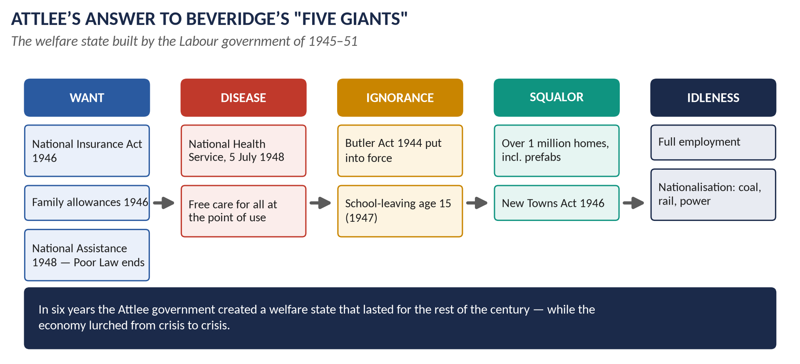
Figure 4 · Attlee's answer to Beveridge's "Five Giants".

5.1 The team
Clement Attlee (PM; modest, efficient chairman), Ernest Bevin (Foreign Secretary), Herbert Morrison (Lord President; nationalisation), Hugh Dalton then Sir Stafford Cripps then Hugh Gaitskell (Chancellors), Aneurin Bevan (Health and Housing).

5.2 The problems in 1945

(i) Economic
- Near bankruptcy: debts, sold investments, lost exports (Chapter 4).
- The "dollar gap": Britain needed American food, raw materials and machines but could not earn enough dollars.
- Demobilisation of about 5 million servicemen; industry to convert from war to peace.
- Costly overseas commitments: Germany, Greece, Palestine, India.

(ii) Social — Beveridge's "Five Giants"
The Beveridge Report (1 December 1942), Social Insurance and Allied Services, identified five evils to be defeated:
1. Want (poverty).
2. Disease (poor health care).
3. Ignorance (poor education).
4. Squalor (bad housing).
5. Idleness (unemployment).

5.3 The social reforms — defeating the Five Giants
Giant | Labour's measures
Want | Family Allowances (1945; paid from 1946, 5s a week for each child after the first); the National Insurance Act (1946): compulsory insurance for everyone — pensions, sickness, unemployment, maternity, widows' and death benefits; the Industrial Injuries Act (1946); the National Assistance Act (1948): a safety net for those not covered — the end of the Poor Law.
Disease | The National Health Service Act (1946); the NHS began on 5 July 1948: free doctors, hospitals, dentists and opticians for all, paid from taxation. Aneurin Bevan overcame the opposition of the doctors (BMA) — he "stuffed their mouths with gold".
Ignorance | The Butler Education Act (1944) put into effect: free secondary education for all (grammar, secondary modern, technical schools; the eleven-plus); school-leaving age raised to 15 (1947).
Squalor | About 1 million homes built (1945–51), including about 157,000 "prefabs"; most were council houses for rent; the New Towns Act (1946) — Stevenage, Harlow, Crawley and others; the Town and Country Planning Act (1947).
Idleness | Full employment (unemployment about 2–3 per cent); nationalisation; regional policy.

Also: the Children Act (1948); the repeal of the Trade Disputes Act of 1927 (1946); the Representation of the People Act (1948) — the end of plural voting; the Parliament Act (1949) — the Lords' delay cut to one year.

5.4 The economic measures

(i) Nationalisation — the "mixed economy"
Year | Industry
1946 | The Bank of England; civil aviation.
1947 | Coal (the National Coal Board, 1 January 1947); cable and wireless.
1948 | Railways, canals, road haulage (British Transport Commission); electricity.
1949 | Gas.
1951 | Iron and steel (after a fight with the Lords).

About 20 per cent of the economy came into public ownership. Owners were compensated.

(ii) Money and trade
- The US loan (1945, $3.75 billion) — with the condition that sterling be made freely convertible into dollars.
- Marshall Aid (1948–51): about $2.7 billion — Britain received the largest share of any country.
- The export drive: "export or die"; exports rose by about 75 per cent above the pre-war level by 1950.
- Austerity under Sir Stafford Cripps (1947–50): high taxes, controls, rationing continued — bread was rationed (1946–48), which had never happened in the war.
- Planning: controls on investment, materials and prices.

5.5 The economic crises
1. The fuel crisis (February 1947): the worst winter of the century; coal could not be moved; power cuts; about 2 million temporarily unemployed.
2. The convertibility crisis (July–August 1947): when sterling became convertible (15 July), holders rushed to swap pounds for dollars; the loan drained away; convertibility was suspended after five weeks (20 August).
3. Devaluation (September 1949): the pound was cut from $4.03 to $2.80 to make exports cheaper.
4. The Korean War (from 1950): rearmament of £4.7 billion strained the economy and led Gaitskell to impose charges for dentures and spectacles (1951); Bevan and Harold Wilson resigned (April 1951), splitting Labour.

5.6 Other achievements
- India, Pakistan, Burma, Ceylon independent (1947–48).
- NATO (1949) and the British atomic bomb programme (decided 1947).
- The Festival of Britain (1951).

5.7 Assessment — how successful?
Successes | Failures and limits
The welfare state — lasting, popular, the basis of British life for generations | Repeated economic crises (1947, 1949, 1951)
Full employment throughout | Continued austerity and rationing; public weariness
Exports revived; Marshall Aid used well | Housing targets missed at first; quality sometimes poor
Over a million homes; New Towns | Nationalised industries not modernised; old management
Peaceful independence for India | Investment in industry neglected (Barnett)
A new consensus accepted by the Conservatives | The party split in 1951; lost the election

Historians: Peter Hennessy (Never Again, 1992) and Kenneth O. Morgan (Labour in Power, 1984) see a remarkable, lasting achievement; Correlli Barnett (The Audit of War, 1986; The Lost Victory, 1995) argues that Britain built a "New Jerusalem" of welfare it could not afford instead of modernising its industry.
The elections: Labour's majority fell to 5 in 1950; in 1951 Labour won more votes than the Conservatives but fewer seats, and Churchill returned.
WHAT THE EXAMINER HAS ASKED · Where Chapters 4–5 have been asked
2019 Q6 (how successfully Labour tackled the economic and social problems of 1945–51). MCQ 2024: the Bank of England was nationalised in 1946.

Chapter 6 · Britain in the Cold War: NATO and the Special Relationship

6.1 How the Cold War began
- Different systems: the USA (capitalist democracy) and the USSR (communist dictatorship) had been allies only against Hitler.
- Eastern Europe: Soviet armies installed communist governments in Poland, Hungary, Romania, Bulgaria and (1948) Czechoslovakia.
- Churchill's "Iron Curtain" speech (Fulton, 5 March 1946).
- Greece and Turkey: in February 1947 Britain told the USA it could no longer afford to support Greece and Turkey against communism; the USA took over — the Truman Doctrine (March 1947), promising to help free peoples resist communism.
- The Marshall Plan (1947–48): American aid to rebuild Europe; Bevin organised the European response.

6.2 Bevin and the making of NATO
- The Treaty of Dunkirk (1947): Britain and France against a revived Germany.
- The Brussels Treaty (March 1948): Britain, France and the Benelux countries — Western Union.
- The Berlin Blockade (June 1948 – May 1949): the Soviets cut off West Berlin; the Berlin Airlift by the US and RAF flew in supplies for almost a year.
- NATO — the North Atlantic Treaty, signed on 4 April 1949 by 12 countries (the USA, Canada, Britain, France, Italy, the Benelux countries, Norway, Denmark, Iceland, Portugal). Article 5: an armed attack on one is an attack on all. Bevin was one of its chief architects. Britain has kept forces in Germany ever since.

6.3 Britain's Cold War commitments
- Nuclear weapons: Attlee's secret decision (1947) — Bevin: "We've got to have the bloody Union Jack on top of it." First British atomic bomb (October 1952, Monte Bello Islands); hydrogen bomb (1957). The 1958 US–UK Mutual Defence Agreement; the US Polaris missile system (Nassau Agreement, December 1962, after the US cancelled Skybolt); Trident (from 1980).
- Korea (1950–53): about 100,000 British troops served; about 1,100 killed (the Glosters at the Imjin River, 1951).
- Malaya (1948–60): the Malayan Emergency against communist guerrillas — won by General Templer's "hearts and minds" and the resettlement of villagers (the Briggs Plan).
- Intelligence: the UKUSA Agreement (1946) — the "Five Eyes" partnership with the USA, Canada, Australia and New Zealand.
- Cuba (1962): Macmillan was consulted by Kennedy during the missile crisis.
- Vietnam: Wilson refused to send troops (1964–68), despite US pressure.
- "East of Suez": after devaluation, Wilson announced (January 1968) withdrawal from bases east of Suez (Singapore, Malaysia, the Gulf) by 1971.

6.4 The special relationship
- The phrase: Churchill at Fulton (1946).
- Foundations: common language and culture, wartime partnership, NATO, nuclear and intelligence cooperation.
- Strains: Suez (1956) — the USA forced Britain to withdraw; Skybolt (1962); Vietnam; Heath's coolness (1970–74) as he turned to Europe; the Yom Kippur War (1973), when Heath refused the US use of British bases.
- Revivals: Macmillan and Eisenhower (Bermuda, 1957), Macmillan and Kennedy; later Thatcher and Reagan, Blair and Clinton/Bush (Topic 9).

6.5 Subservient to the USA? — the long view (1945–2026)
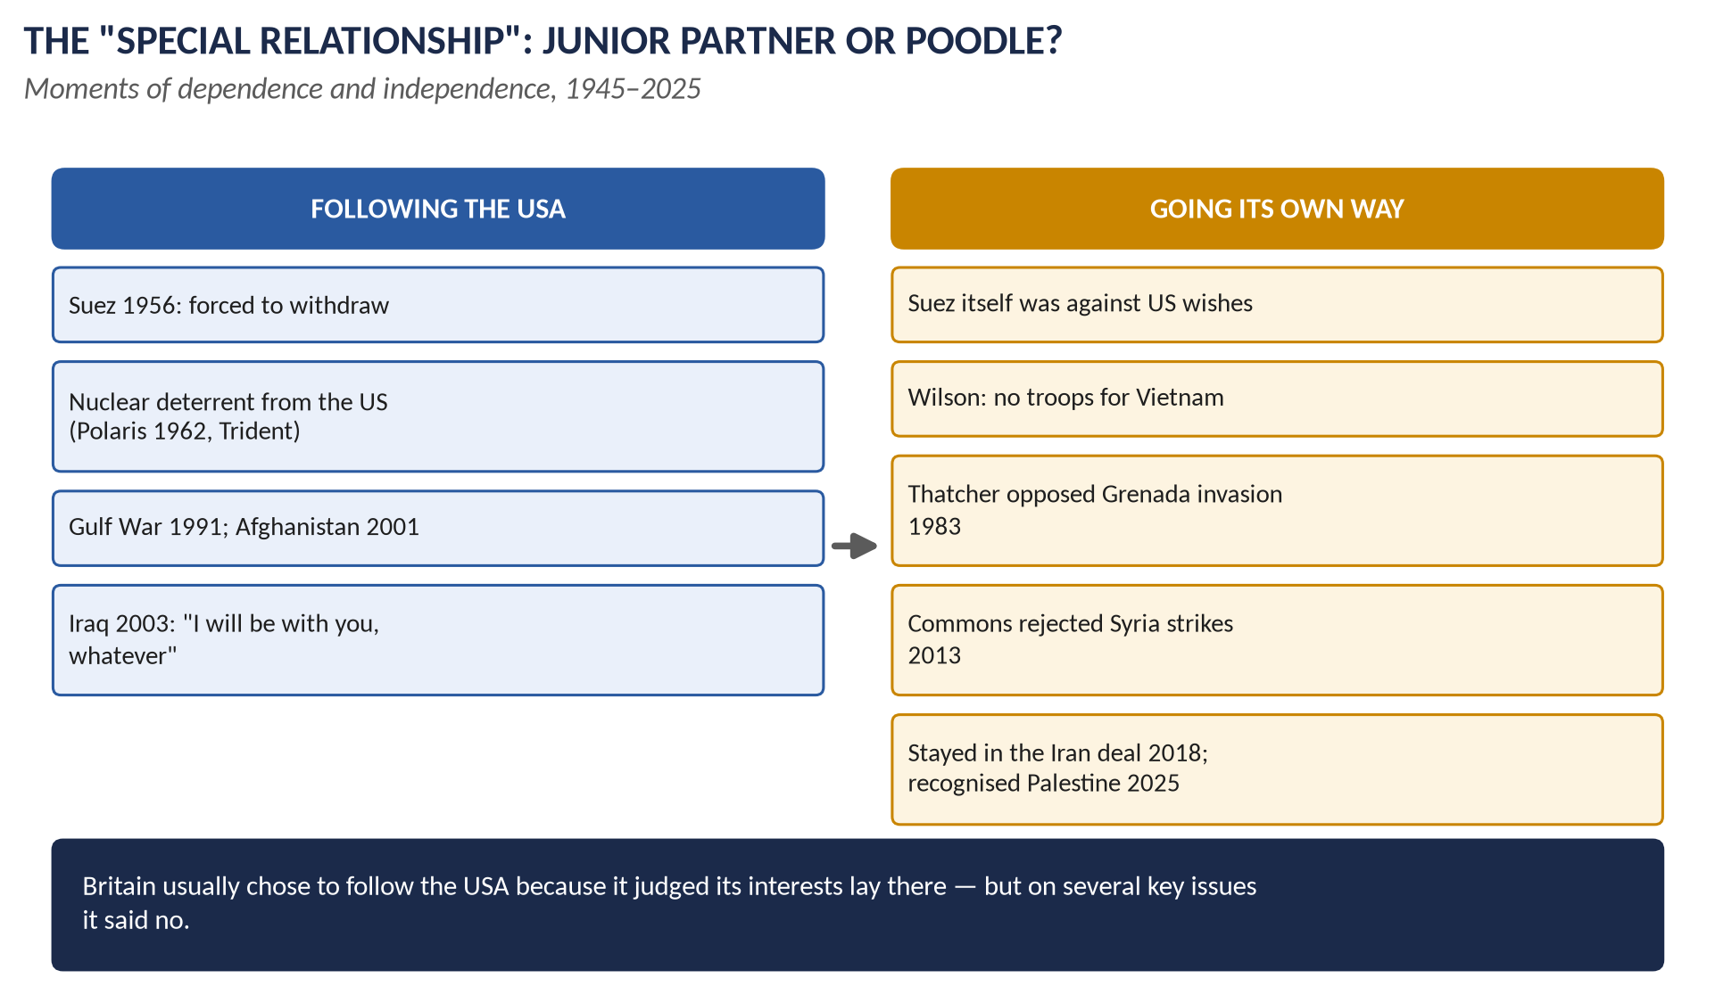
Figure 5 · The special relationship: junior partner or poodle?

(i) Why some believe Britain was subservient
1. Money: the US loan (1945), Marshall Aid, and the US pressure on sterling at Suez (1956) showed Britain could not act against America.
2. Nuclear dependence: Polaris (1962) and Trident — Britain's deterrent depends on US missiles.
3. Bases: US bombers and missiles in Britain (Greenham Common's cruise missiles, 1983); the Libya bombing (1986) launched from British bases.
4. Wars: the Gulf War (1991); Kosovo (1999); Afghanistan (from October 2001) after 9/11 — Blair pledged to stand "shoulder to shoulder" with America.
5. Iraq (2003): Blair joined the US invasion despite mass protests (about 1 million marched in London, February 2003) and no second UN resolution. The Chilcot Report (July 2016) revealed his note to President Bush (July 2002): "I will be with you, whatever." Critics called him "Bush's poodle".
6. Unequal treaties: the 2003 Extradition Treaty was said to favour the USA.

(ii) Evidence of independence
1. Suez itself (1956) was launched against US wishes.
2. Vietnam: Wilson refused troops.
3. Heath put Europe first; he denied the US bases in 1973.
4. Thatcher protested at the US invasion of Grenada (a Commonwealth country, 1983) and opposed parts of Reagan's nuclear plans after Reykjavik (1986).
5. Blair pressed Bush to go to the UN (Resolution 1441, November 2002) and to pursue the Middle East peace process.
6. Syria (August 2013): the Commons voted against military action (285 to 272); Britain did not join US strikes then.
7. China: Britain joined the China-led Asian Infrastructure Investment Bank (2015) against US wishes.
8. Iran: Britain stayed in the Iran nuclear deal after the US left it (2018) — though in 2025 Britain, France and Germany triggered the return of UN sanctions.
9. Palestine: Britain recognised the State of Palestine (September 2025), a step the US opposed.

(iii) Explaining the pattern
Britain has usually followed the USA because it judged that its interests — security, nuclear and intelligence cooperation, influence in Washington — lay there, and because the two countries shared values. "Hugging close" was a deliberate strategy to gain influence. So Britain has been a dependent partner, often too willing to follow, but not a servant: when its interests or Parliament disagreed, it said no. Recent examples of partnership by choice include AUKUS (2021, with Australia and the USA) and support for Ukraine (from 2022).
WHAT THE EXAMINER HAS ASKED · Where Chapter 6 has been asked
2018 Q7: why some believe Britain was subservient to the US line during the Cold War and after 9/11 — do you agree?

Chapter 7 · The Commonwealth
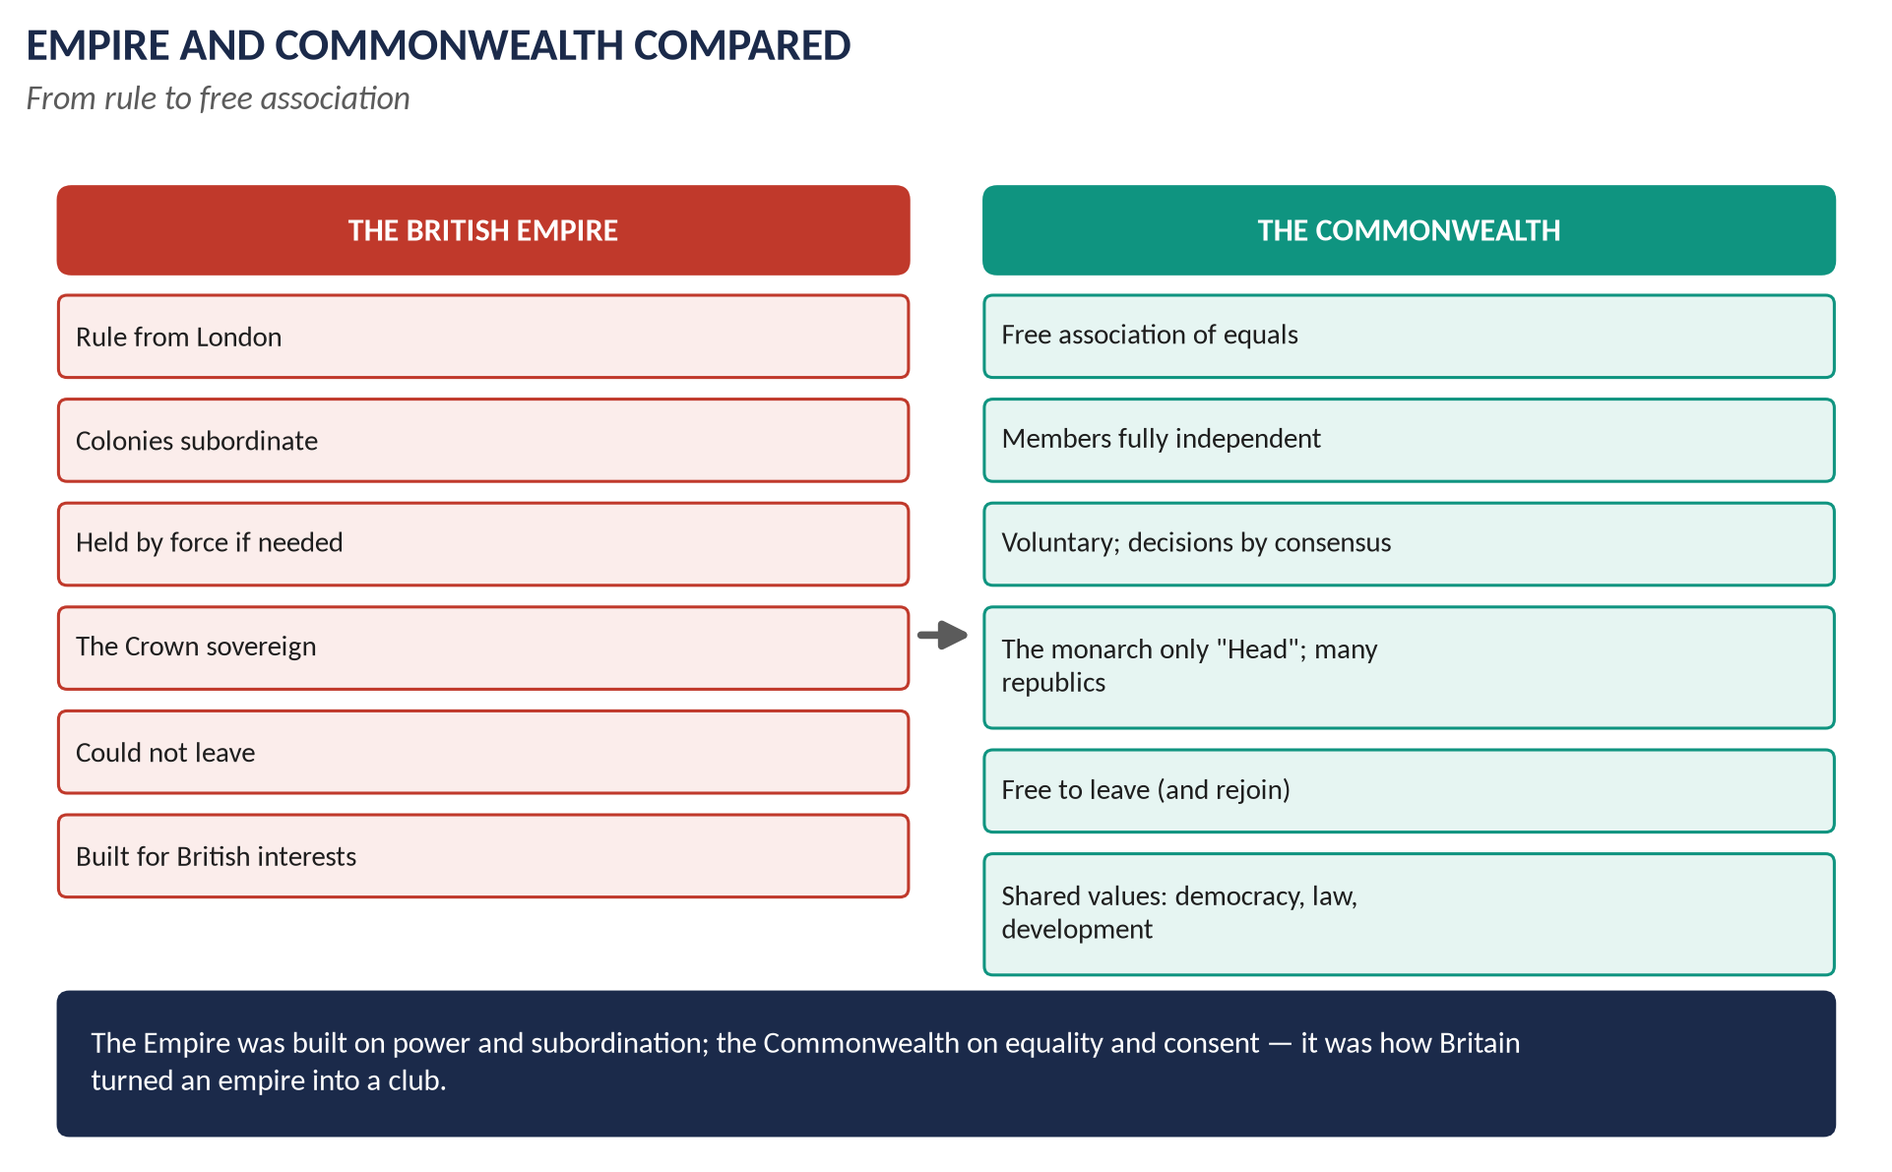
Figure 6 · Empire and Commonwealth compared.

7.1 What is the Commonwealth?
The Commonwealth of Nations is a voluntary association of 56 independent and equal countries, almost all of them former parts of the British Empire, which cooperate on the basis of shared values — democracy, human rights, the rule of law, development. The British monarch (now King Charles III) is its symbolic Head. It has about 2.7 billion people — about a third of the world's population.

7.2 The development of the idea — stage by stage

Stage 1 · Self-government for the settler colonies (1839–1914)
- The Durham Report (1839), after rebellions in Canada, recommended responsible government — colonial ministers answerable to their own elected assemblies.
- The Dominions: Canada (1867), Australia (1901), New Zealand (1907), Newfoundland (1907), South Africa (1910) — self-governing in domestic affairs, though Britain still controlled foreign policy.
- The phrase: Lord Rosebery (1884) described the Empire as "a commonwealth of nations".
- Colonial Conferences (from 1887), later Imperial Conferences (1907).

Stage 2 · From Dominions to equals (1914–1931)
- The First World War: the Dominions sent over a million men; they signed the peace treaties and joined the League of Nations separately.
- Jan Smuts (South Africa) spoke of the "British Commonwealth of Nations" (1917); the term appeared in the Anglo-Irish Treaty (1921); the Irish Free State became a Dominion (1922).
- Chanak (1922): the Dominions refused to follow Britain into war automatically.
- The Balfour Declaration (1926) defined Britain and the Dominions as "autonomous communities within the British Empire, equal in status, in no way subordinate one to another in any aspect of their domestic or external affairs, though united by a common allegiance to the Crown, and freely associated as members of the British Commonwealth of Nations".
- The Statute of Westminster (11 December 1931) gave this legal force: British laws no longer applied to a Dominion unless it asked; the Dominions were fully sovereign.

Stage 3 · The modern, multiracial Commonwealth (1947–1965)
- India, Pakistan and Ceylon (1947–48) joined as the first non-white members; Burma (1948) did not join.
- The London Declaration (April 1949): India wished to become a republic but stay a member. The prime ministers agreed that a republic could remain in, recognising the King as "the symbol of the free association of its independent member nations and as such the Head of the Commonwealth". The word "British" was dropped — it became simply the Commonwealth of Nations. This is often called the creation of the modern Commonwealth.
- Ireland left (1949) on becoming a republic.
- Decolonisation (1957 onwards): new African, Asian and Caribbean states joined — Ghana and Malaya (1957), Nigeria (1960) and many more. The white Dominions became a minority.
- South Africa left in 1961 over apartheid (it rejoined in 1994 after Mandela's election).
- The Commonwealth Secretariat (1965) in London; first Secretary-General Arnold Smith (Canada). The Commonwealth became an organisation of members, not a British institution.

Stage 4 · A community of values (1971–2026)
- The Singapore Declaration (1971): shared principles — peace, liberty, racial equality.
- The Gleneagles Agreement (1977): a sporting boycott of apartheid South Africa.
- The Harare Declaration (1991): democracy, human rights, good governance.
- Enforcement: members suspended for military coups or abuses (Nigeria 1995; Zimbabwe 2002, which left in 2003; Pakistan 1999; Fiji).
- The Commonwealth Charter (2013): sixteen core values.
- New members with no British colonial link: Mozambique (1995), Rwanda (2009), Gabon and Togo (2022).
- Headship: Elizabeth II (1952–2022) — the members agreed in 2018 that Charles would succeed her; King Charles III became Head in 2022.
- Today: 56 members; the Commonwealth Games; scholarships; trade; small-state support; the CHOGM in Samoa (2024) — the first in the Pacific — discussed reparatory justice for slavery; Secretary-General Shirley Botchwey (Ghana) from 2025.

7.3 How the Commonwealth differs from the Empire
Point | British Empire | Commonwealth
Basis | Conquest, settlement, treaty — power | Voluntary free association — consent
Status | Colonies subordinate to Britain | Members equal and fully sovereign
Government | Ruled or supervised from London (Colonial Office, Viceroys, Governors) | Each member governs itself; a Secretariat serves them all
The Crown | Sovereign ruler of all | Symbolic Head; most members are republics or have their own monarchs
Force | Maintained by armies when needed (India 1857, Kenya) | No force; members can leave freely and rejoin (Pakistan, South Africa)
Decisions | British decisions | Consensus at meetings (CHOGM)
Purpose | British trade, strategy, prestige | Cooperation, development, democracy, shared values
Membership | British possessions only | Includes states that were never British colonies (Mozambique, Rwanda)
Character | Led and dominated by Britain; racially hierarchical | Multiracial; the majority in Africa, Asia, the Caribbean and Pacific

7.4 The significance of the Commonwealth
- It eased the end of empire: Britain could present decolonisation as an evolution, not a defeat, and new states kept links with Britain.
- Influence, not power: diplomacy, trade, education, legal systems and the English language.
- Moral leadership: the struggle against apartheid and Rhodesian white-minority rule.
- Limits: no binding powers; Britain's own turn to Europe (1973) weakened trade links; critics call it a talking shop or a relic of empire; debates on slavery reparations.
WHAT THE EXAMINER HAS ASKED · Where Chapter 7 has been asked
2015 P-II Q6 (how the idea developed; how it differs from the Empire) · 2017 Q7 (the same) · 2024 Q7(c) (short note: the creation of the Commonwealth).

Chapter 8 · Decolonisation

8.1 What decolonisation means
Decolonisation is the process by which colonies gained independence from their colonial rulers. Britain's empire in 1945 covered about 700 million people; by 1970 most of it had gone, and by 1997 (Hong Kong) almost all.
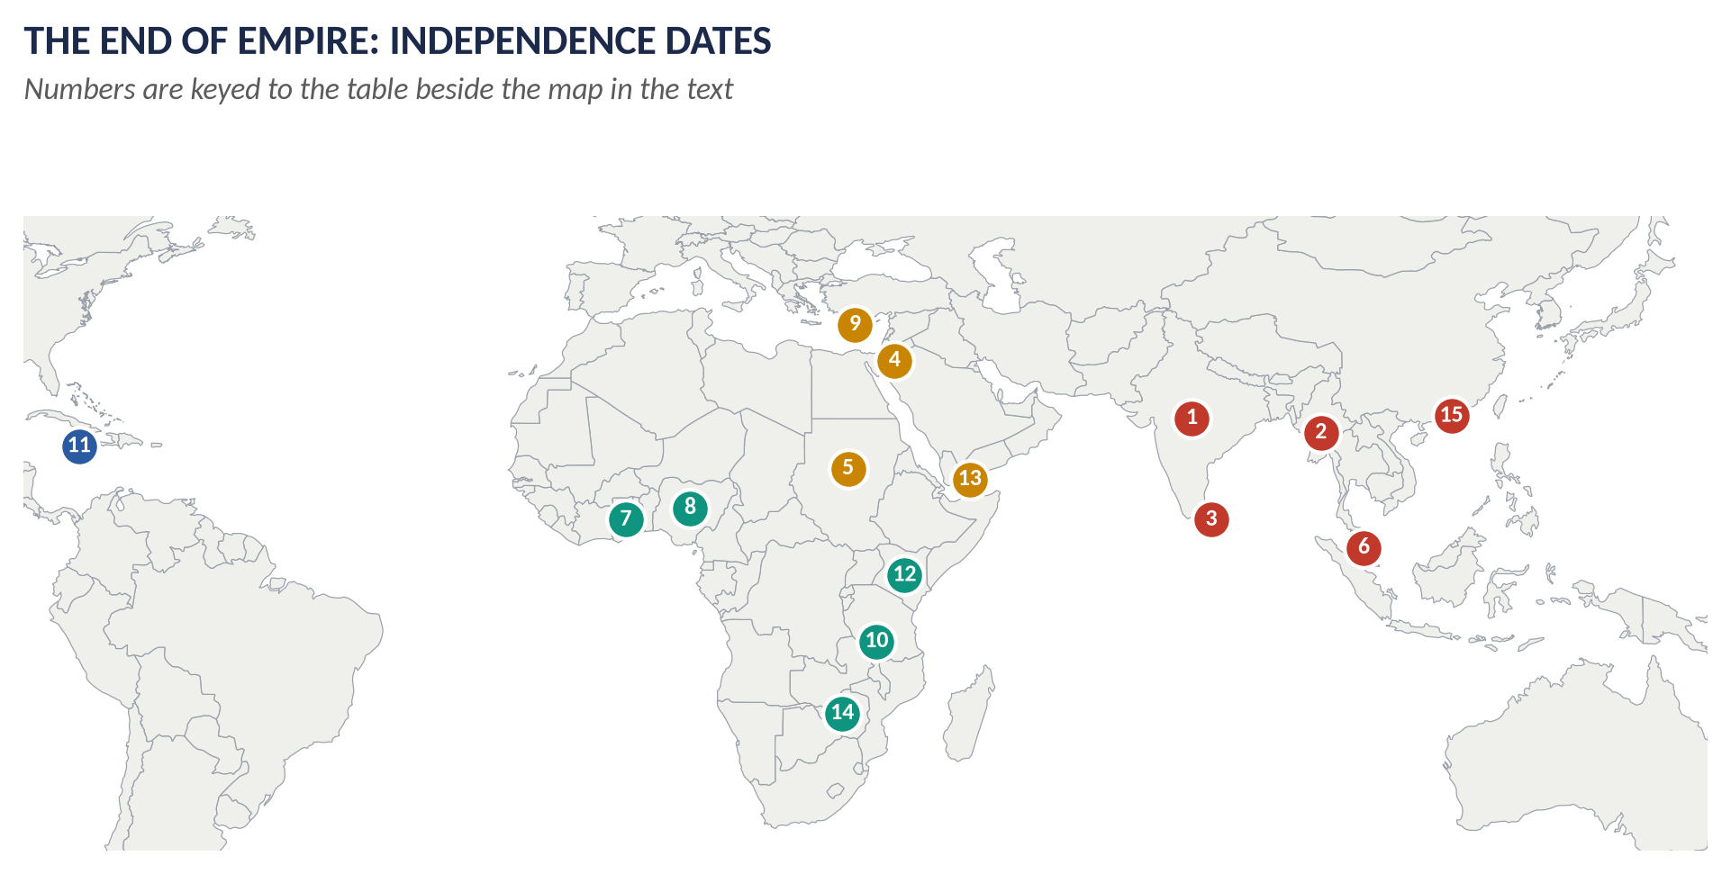
Figure 7 · The end of empire: numbered independence dates (key below).
1 | India and Pakistan | 1947 | 9 | Cyprus | 1960
2 | Burma | 1948 | 10 | Tanganyika (Tanzania) | 1961
3 | Ceylon (Sri Lanka) | 1948 | 11 | Jamaica | 1962
4 | Palestine (mandate ended) | 1948 | 12 | Kenya | 1963
5 | Sudan | 1956 | 13 | Aden (South Yemen) | 1967
6 | Malaya | 1957 | 14 | Rhodesia → Zimbabwe | 1980
7 | Gold Coast → Ghana | 1957 | 15 | Hong Kong (to China) | 1997
8 | Nigeria | 1960

8.2 The motives — why Britain decolonised
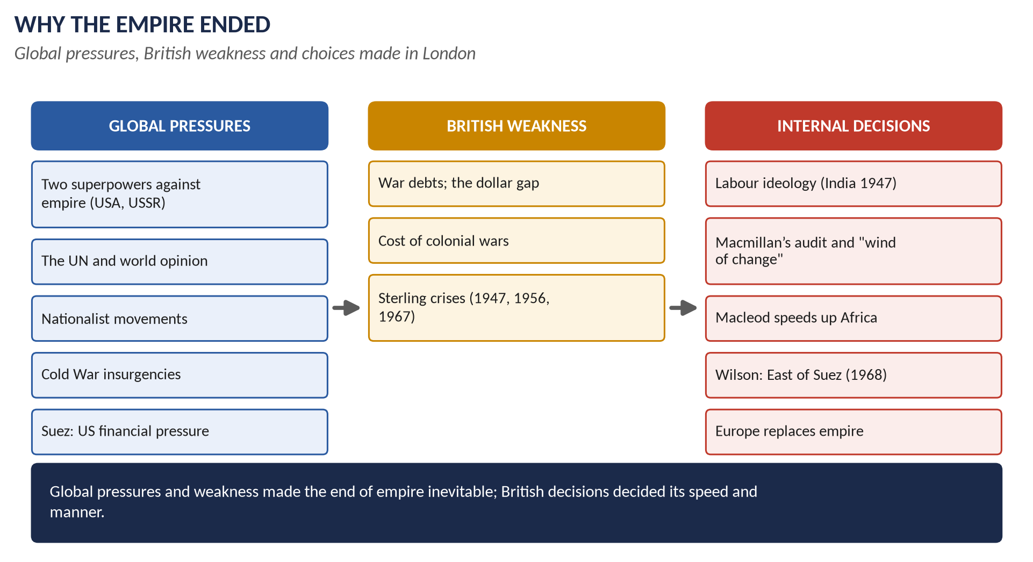
Figure 8 · Why the Empire ended.

(i) Economic weakness
- Britain was deeply in debt after 1945; it could not afford to hold down colonies by force.
- Colonial wars were expensive: Malaya, Kenya, Cyprus, Aden.
- Repeated sterling crises (1947, 1949, 1956, 1967).

(ii) Nationalism
Strong nationalist movements — the Indian Congress and Muslim League, Nkrumah's Convention People's Party in the Gold Coast, Kenyatta's KANU in Kenya — made colonial rule impossible without force.

(iii) The Second World War
The fall of Singapore (1942) destroyed British prestige; the Atlantic Charter and colonial soldiers' service raised expectations; India was promised independence.

(iv) International pressure
- The USA opposed old-style empires (Roosevelt; Eisenhower at Suez).
- The USSR supported "national liberation" movements.
- The United Nations: its Charter proclaimed self-determination; the Declaration on the Granting of Independence to Colonial Countries and Peoples (Resolution 1514, December 1960).

(v) The Cold War
Britain needed to hand power to moderate, pro-Western nationalists before communists took over (Malaya); fighting colonial wars damaged its image; resources were needed for NATO and nuclear weapons.

(vi) British decisions and attitudes
- Labour's anti-imperial ideals (India, 1947).
- Macmillan's audit of the colonies' costs and benefits (1957) and his "wind of change" speech (Cape Town, 3 February 1960): "The wind of change is blowing through this continent, and whether we like it or not, this growth of national consciousness is a political fact."
- Iain Macleod (Colonial Secretary, 1959–61) speeded up independence in Africa.
- Suez (1956) showed Britain could no longer act as an imperial power.
- Europe: from 1961 Britain looked to the EEC rather than the empire.
- Public opinion was largely indifferent; scandals such as the Hola camp killings in Kenya (March 1959, 11 detainees beaten to death) and the Devlin Report on Nyasaland (1959: "a police state") turned opinion against colonial rule.

(vii) The Commonwealth as a bridge
Independence within the Commonwealth let Britain keep friendship and influence.

8.3 India, 1947

(i) Why Britain left
1. Indian nationalism: the Indian National Congress (1885) under Gandhi and Nehru, with mass campaigns of non-cooperation (1920–22), civil disobedience (the Salt March, 1930), and Quit India (August 1942).
2. The Muslim League under Jinnah demanded a separate homeland — the Lahore Resolution (23 March 1940); the League won almost all Muslim seats in the 1945–46 elections.
3. The war weakened Britain; Cripps had promised independence after the war (1942); India became Britain's creditor (the sterling balances).
4. Loss of control: the INA trials (1945–46, of soldiers of Subhas Chandra Bose's Indian National Army) roused huge public sympathy; the Royal Indian Navy mutiny (February 1946) showed the armed forces could no longer be relied on; the Indian Civil Service was now largely Indian.
5. Labour's commitment: Attlee and his colleagues believed in Indian independence.
6. US pressure and world opinion.
7. Cost: holding India by force would need troops Britain did not have.

(ii) How Britain left
Date | Step
March 1942 | The Cripps Mission: dominion status after the war, with the right of provinces to opt out; rejected ("a post-dated cheque on a failing bank", as Gandhi reportedly called it).
Aug 1942 | Quit India; Congress leaders imprisoned for the rest of the war.
June–July 1945 | The Simla Conference (Viceroy Wavell) failed over Muslim representation.
1945–46 | Elections: Congress won the general seats, the League almost all Muslim seats.
Mar–June 1946 | The Cabinet Mission (Pethick-Lawrence, Cripps, Alexander): a loose federal union with three groups of provinces (the 16 May plan); first accepted by the League, then collapsed over interpretation.
16 Aug 1946 | Direct Action Day called by the League; the Great Calcutta Killings — about 4,000 dead; violence spread to Noakhali, Bihar and the Punjab.
Sept 1946 | An interim government under Nehru; the League joined in October but cooperation failed.
20 Feb 1947 | Attlee announced that Britain would leave by June 1948.
Mar 1947 | Lord Mountbatten became the last Viceroy.
3 June 1947 | The 3 June Plan (Mountbatten Plan): partition into India and Pakistan, with Bengal and the Punjab divided; the date brought forward to August 1947.
July 1947 | The Indian Independence Act (royal assent 18 July).
14–15 Aug 1947 | Pakistan (14 August) and India (15 August) became independent Dominions.
17 Aug 1947 | The Radcliffe Line borders announced.

(iii) The consequences
- Partition violence: an estimated several hundred thousand to over a million killed; about 12–15 million people displaced — one of the largest migrations in history.
- The princely states joined India or Pakistan; Kashmir became a lasting source of conflict (war 1947–48).
- Gandhi was assassinated (January 1948).
- Both new states stayed in the Commonwealth; India's wish to be a republic led to the London Declaration (1949).
- Judgement: Britain's speed avoided being caught in a civil war and a costly holding operation, but critics blame the rushed timetable (Mountbatten) and the hasty borders for the scale of the slaughter.

8.4 Other major cases

(i) Malaya (1948–1957)
A communist insurgency (mainly among the Chinese population) was defeated in the Malayan Emergency through military action, resettlement and a promise of independence; Malaya became independent on 31 August 1957 under Tunku Abdul Rahman; Malaysia (with Singapore, Sarawak and Sabah) formed in 1963; Singapore separated in 1965.

(ii) The Gold Coast → Ghana (1957)
Kwame Nkrumah's mass party won elections (1951, 1954, 1956); the first sub-Saharan colony to win independence (6 March 1957) — a model for the rest of Africa.

(iii) Kenya (1952–1963)
- A settler colony with white farmers in the "White Highlands".
- The Mau Mau rising (1952–60) among the Kikuyu: about 11,000 rebels and some 2,000 loyalist Africans killed, 32 white settlers; tens of thousands of Kikuyu held in detention camps; the Hola camp killings (1959).
- Macleod and the Lancaster House conferences (1960, 1962) moved to majority rule; Jomo Kenyatta, once imprisoned, became leader; independence on 12 December 1963.
- In 2013 the British government paid £19.9 million to about 5,000 Kenyan victims of abuse.

(iv) The wind of change (1960–1966)
Nigeria (1960), Cyprus (1960, after the EOKA insurgency), Sierra Leone (1961), Tanganyika (1961), Uganda (1962), Jamaica and Trinidad (1962), Kenya (1963), Malawi and Zambia (1964, after the break-up of the Central African Federation), Gambia (1965), Botswana and Lesotho (1966).

(v) Aden (1967)
Britain's base at Aden guarded the route to India and the Gulf. A nationalist insurgency (1963–67) and the 1966 Defence Review led to a hasty withdrawal (November 1967).

(vi) Rhodesia (1965–1980)
The white minority under Ian Smith declared UDI (Unilateral Declaration of Independence) on 11 November 1965 to avoid majority rule. Wilson refused to use force; UN sanctions failed; a guerrilla war followed. The Lancaster House Agreement (December 1979) led to elections and the independence of Zimbabwe (18 April 1980) under Robert Mugabe.

(vii) Hong Kong (1997)
The lease on the New Territories expired in 1997. The Sino-British Joint Declaration (1984) agreed the return of all Hong Kong to China under "one country, two systems" for 50 years; handover on 1 July 1997.

8.5 Global pressures or British decisions? — weighing the causes
Case | Global pressures | British decisions
India 1947 | Nationalism; war weakness; US and world opinion | Attlee's ideology and deadline (Feb 1947); Mountbatten's timetable
Suez 1956 | US financial pressure on sterling; UN; USSR | Eden's decision to invade — and to withdraw
Ghana 1957 | Nationalism; example for Africa | Colonial Office's gradual plan with Nkrumah
Kenya 1963 | Mau Mau; world opinion after Hola | Macleod's decision to move fast to majority rule
Aden 1967 | Insurgency; Arab nationalism | The 1966 Defence Review; economy cuts
East of Suez 1968 | Sterling crisis; US involvement in Asia | Wilson's decision after devaluation
Hong Kong 1997 | China's power; the lease | Thatcher's negotiated Joint Declaration (1984)

Judgement: global pressures and British weakness set the direction — empire could not last; British political decisions set the pace and manner — fast or slow, peaceful or violent, within the Commonwealth or not.
WHAT THE EXAMINER HAS ASKED · Where Chapter 8 has been asked
2019 Q7 (motives; why and how Britain left India) · 2024 Q6 (how WWII and the Cold War triggered decolonisation) · 2026 Q4 (global pressures v internal decisions, with three cases). MCQs 2025: former colonies gained independence through decolonisation; 2024: apartheid was in South Africa.

Chapter 9 · The Middle East, Palestine and Suez
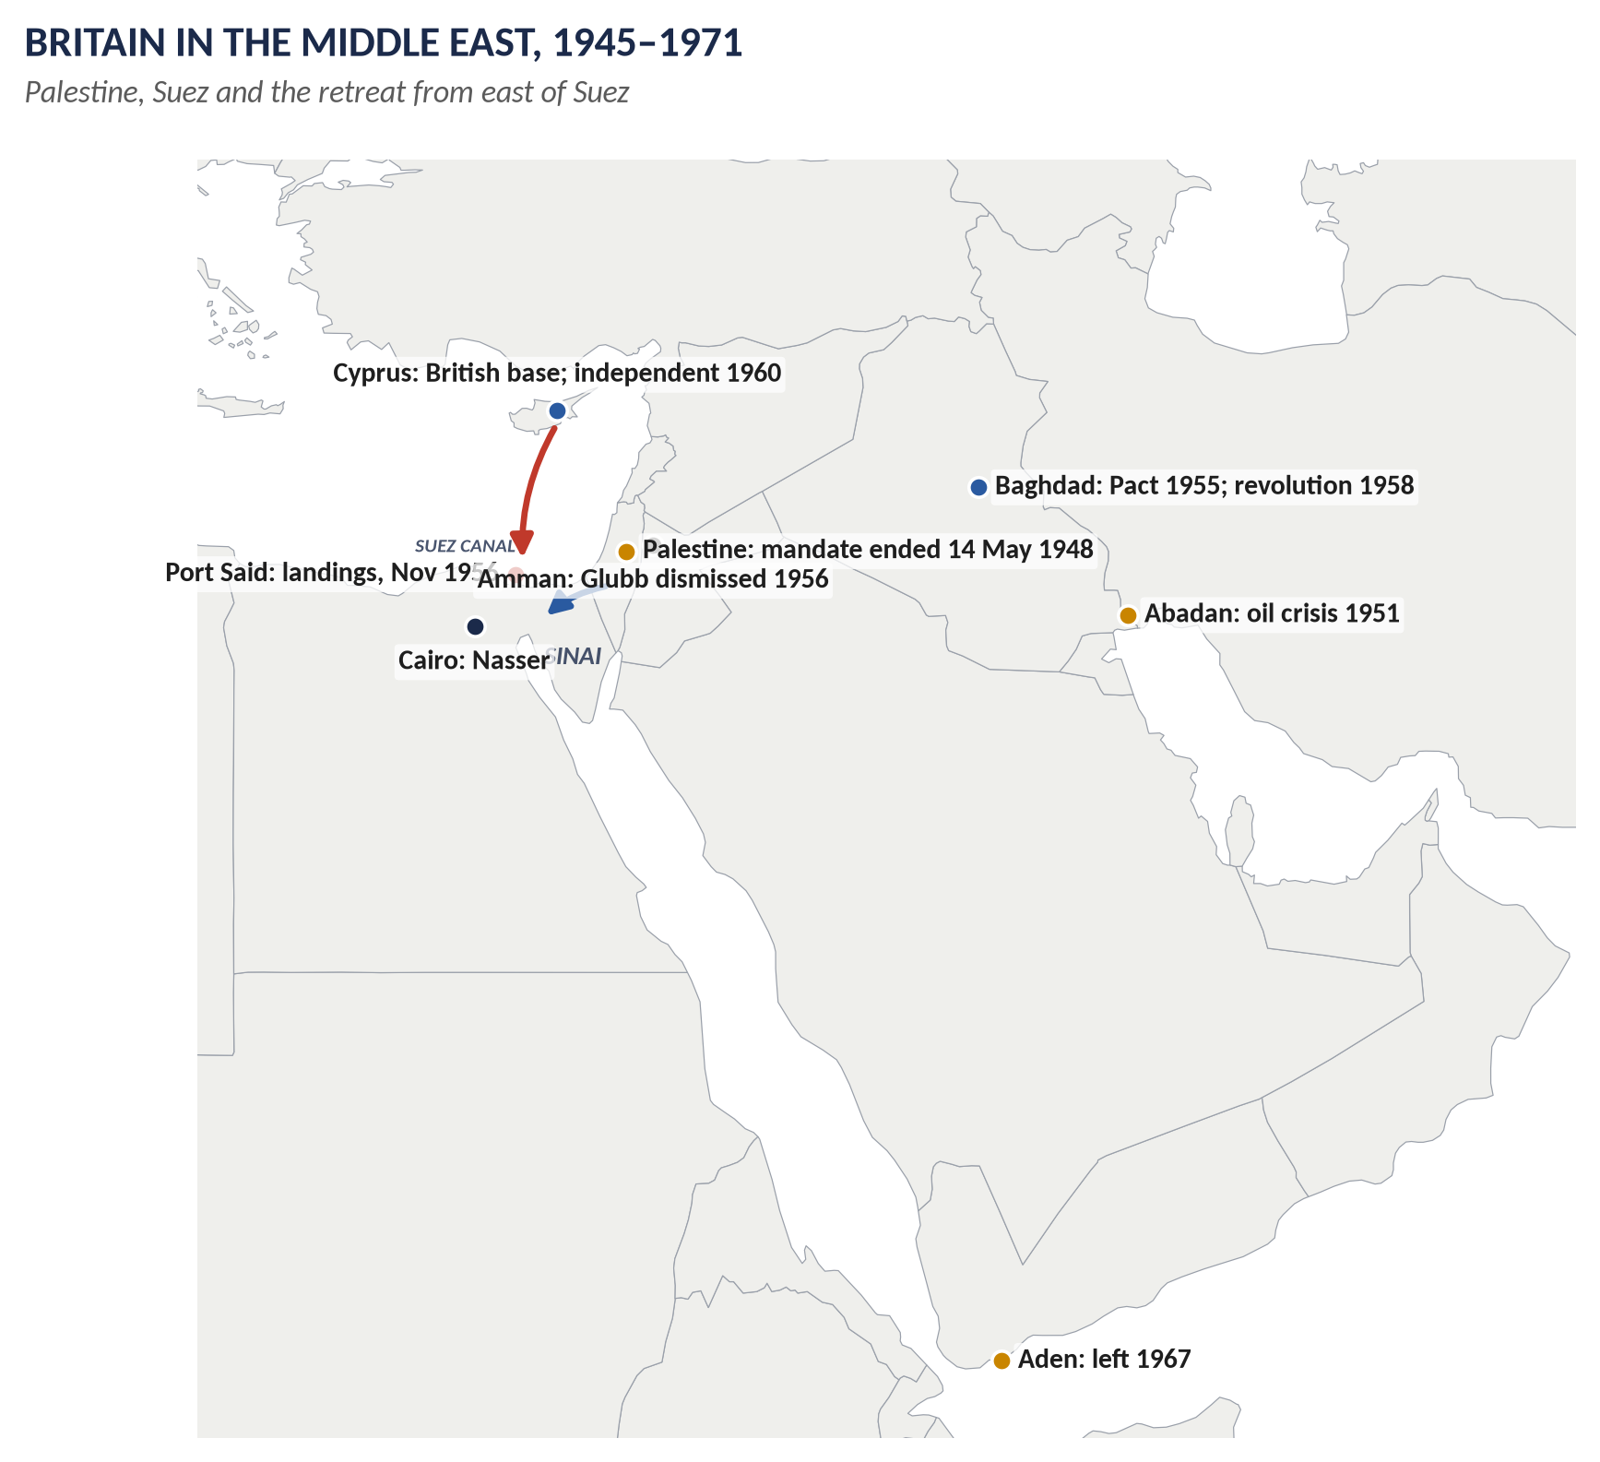
Figure 9 · Britain in the Middle East, 1945–1971.

9.1 Britain in the Middle East
- Interests: the Suez Canal (route to India and the East), oil (Iran, Iraq, the Gulf), bases (Egypt, Cyprus, Aden, Iraq), and keeping out the USSR.
- After 1918: League mandates over Palestine, Transjordan and Iraq; British influence over Egypt (independent in name from 1922; the Anglo-Egyptian Treaty, 1936, kept British troops in the Canal Zone).
- After 1945: rising Arab nationalism; the Cold War.

9.2 Palestine (1917–1948)

(i) The problem Britain created
- The McMahon–Hussein correspondence (1915–16) seemed to promise Arab independence.
- The Balfour Declaration (2 November 1917) promised "a national home for the Jewish people" in Palestine, without prejudice to the rights of the existing non-Jewish communities.
- The Mandate (1920, confirmed 1922): Jewish immigration grew, especially after Hitler came to power (1933).

(ii) The inter-war conflict
- The Arab Revolt (1936–39) against Jewish immigration and British rule.
- The Peel Commission (1937) proposed partition.
- The 1939 White Paper limited Jewish immigration to 75,000 over five years and promised an independent, Arab-majority Palestine within ten years — angering the Zionists.

(iii) Why Britain withdrew (1945–1948)
1. Jewish insurgency: the Irgun and Lehi ("Stern Gang") attacked the British; the King David Hotel bombing (22 July 1946, 91 killed); the hanging of two British sergeants (1947).
2. Impossible promises: Arabs and Jews wanted opposite things; any policy angered one side.
3. US pressure: President Truman demanded the admission of 100,000 Jewish refugees, survivors of the Holocaust; the Exodus affair (1947) shamed Britain.
4. Cost: about 100,000 troops were tied down at a time of economic crisis.
5. Bevin referred the problem to the UN (February 1947).
6. UN partition: Resolution 181 (29 November 1947) proposed separate Jewish and Arab states and an international Jerusalem; Britain abstained and refused to enforce it.
7. Withdrawal: the mandate ended on 14–15 May 1948; Israel was proclaimed on 14 May; the first Arab–Israeli war followed; about 700,000 Palestinians fled or were expelled (the Nakba).

9.3 Other crises of influence
- Iran (1951–53): Mossadegh nationalised the Anglo-Iranian Oil Company (Abadan); an Anglo-American-backed coup overthrew him (1953).
- The Baghdad Pact (1955): Britain, Turkey, Iraq, Iran and Pakistan against Soviet influence.
- Jordan: King Hussein dismissed the British commander Glubb Pasha (March 1956).
- Iraq: the pro-British monarchy was overthrown (July 1958).

9.4 The Suez Crisis (1956)

(i) The background
- The canal: opened 1869; Britain bought the Khedive's shares (1875) and occupied Egypt (1882). In the 1950s two-thirds of Europe's oil came through it.
- Nasser: Colonel Gamal Abdel Nasser came to power after the 1952 revolution; a hero of Arab nationalism.
- The 1954 agreement: Britain agreed to withdraw its troops from the Canal Zone within 20 months; the last left in June 1956.
- Tension: Nasser opposed the Baghdad Pact; bought Czech (Soviet-bloc) arms (1955); supported Algerian rebels against France and raids into Israel.
- The Aswan Dam: the USA and Britain withdrew their offer of loans for Nasser's great dam (19 July 1956).

(ii) The crisis
Date | Event
26 July 1956 | Nasser nationalised the Suez Canal Company to pay for the dam.
Aug–Oct 1956 | Conferences in London; the Suez Canal Users' Association; negotiations at the UN. Eden, who compared Nasser with Mussolini, prepared military action with France.
22–24 Oct 1956 | The secret Protocol of Sèvres: Britain, France and Israel agreed that Israel would attack Egypt, giving Britain and France an excuse to intervene to "separate the combatants" and seize the canal.
29 Oct | Israel invaded Sinai.
30 Oct | The Anglo-French ultimatum to both sides to withdraw from the canal.
31 Oct | British and French aircraft bombed Egyptian airfields; Nasser blocked the canal with sunken ships.
2 Nov | The UN General Assembly, on a US motion, demanded a ceasefire (64 to 5).
5–6 Nov | Operation Musketeer: British and French paratroops and seaborne forces landed at Port Said and advanced along the canal.
5 Nov | The USSR threatened rocket attacks on London and Paris (Hungary was being crushed at the same time).
6 Nov | Facing a run on the pound and US refusal to support an IMF loan unless Britain stopped, Eden accepted a ceasefire at midnight.
Nov–Dec | A UN Emergency Force (proposed by Canada's Lester Pearson) took over; British and French forces left by 22 December 1956.
9 Jan 1957 | Eden resigned (officially for ill health); Macmillan became PM.

(iii) Why Britain withdrew from Suez
1. US opposition — decisive: Eisenhower was furious at not being consulted, feared driving the Arab world to the USSR, and was fighting an election; the US refused financial help while sterling was under attack.
2. The run on sterling: Britain was losing its reserves; oil supplies were cut.
3. The UN: almost the whole world condemned the invasion.
4. The Soviet threat.
5. The Commonwealth was divided (India, Canada opposed).
6. Opposition at home: Labour (Gaitskell) and part of the press and public; two ministers resigned.

(iv) Consequences
- The end of Britain as an independent great power: it could not act against US wishes.
- The special relationship was repaired by Macmillan — Britain would never again oppose the USA on a major issue.
- Faster decolonisation: Macmillan's audit, the "wind of change".
- France turned towards Europe (the Treaty of Rome, 1957) and its own nuclear force.
- Nasser became the hero of the Arab world; British influence in the Middle East declined (Iraq 1958, Aden 1967, the Gulf 1971).
- The Eisenhower Doctrine (1957): the USA replaced Britain as the Western power in the Middle East.
WHAT THE EXAMINER HAS ASKED · Where Chapter 9 has been asked
2020 Q6 (the Middle East and Suez; why England withdrew from Palestine and the canal) · 2022 Q8(b) (short note: the Suez Crisis). MCQ 2026: the Suez Crisis resulted in British withdrawal.

Chapter 10 · Home and Europe, 1951–1979

10.1 The Conservative years (1951–1964)
- Churchill (1951–55): accepted the welfare state; denationalised steel and road haulage; 300,000 houses a year (1953); rationing ended (4 July 1954); the coronation of Elizabeth II (2 June 1953).
- Eden (1955–57): Suez.
- Macmillan (1957–63): the "affluent society" — cars, televisions, washing machines; "Most of our people have never had it so good" (July 1957); "stop-go" economics; the Profumo affair (1963).
- Home (1963–64).
- "Butskellism": both parties accepted the welfare state, full employment and a mixed economy.

10.2 The Wilson years (1964–1970)
- "The white heat of technology" (1963).
- Devaluation (November 1967): $2.80 → $2.40; "the pound in your pocket" has not been devalued.
- Social reforms: the Open University, the abolition of hanging, the Race Relations Acts, the Equal Pay Act (1970).
- "Swinging London": the Beatles, fashion (Carnaby Street, the miniskirt), Time magazine's cover "London: The Swinging City" (April 1966).
- In Place of Strife (1969): a plan to reform unions — dropped after opposition.
- Northern Ireland: the Troubles began (1968–69); troops sent (August 1969).

10.3 Heath (1970–1974)
- EEC entry (1 January 1973).
- Decimal currency (15 February 1971).
- The Industrial Relations Act (1971); miners' strikes (1972, 1974); the oil crisis (1973); the three-day week (January–March 1974); "Who governs Britain?" — Heath lost the February 1974 election.

10.4 Wilson and Callaghan (1974–1979)
- The EEC referendum (5 June 1975): 67 per cent voted to stay in.
- Inflation reached about 25 per cent (1975).
- The IMF loan (1976): $3.9 billion, in return for spending cuts — a national humiliation.
- The Lib-Lab Pact (1977–78).
- The Winter of Discontent (1978–79): strikes by lorry drivers, public-sector workers, refuse collectors and gravediggers against the government's 5 per cent pay limit; "Crisis? What crisis?" (The Sun's headline about James Callaghan, January 1979).
- The fall: the government lost a vote of no confidence by one vote (311 to 310, 28 March 1979); Margaret Thatcher won the election of May 1979.

10.5 Britain and the EEC
Year | Event
1950–51 | Britain stayed out of the Schuman Plan (the European Coal and Steel Community).
1957 | The Treaty of Rome created the EEC (France, West Germany, Italy, the Benelux countries); Britain stayed out, preferring the Commonwealth, the USA and national sovereignty.
1960 | Britain formed EFTA (the European Free Trade Association) with six other states — much weaker.
1961 | Macmillan applied to join (negotiator Edward Heath) — after Suez, slow growth and the decline of Commonwealth trade.
14 Jan 1963 | De Gaulle's veto ("Non!"): Britain was too tied to the USA (the Nassau deal) and its Commonwealth, and "insular".
1967 | Wilson applied again — vetoed by de Gaulle (November 1967).
1969 | De Gaulle resigned; Pompidou was more open.
1972–73 | Heath negotiated entry; Britain joined on 1 January 1973 with Ireland and Denmark.
1975 | Referendum: 67% Yes.
2016–2020 | The story continues in Topics 9–10: the Brexit referendum (2016) and departure (31 January 2020).

Chapter 11 · The Legacy — to 2026
Theme | What happened later
The Second World War | 80th anniversaries of VE and VJ Day in 2025; the war remains central to British identity.
Churchill | Voted "Greatest Briton" (2002); debates about his imperial record continue.
The welfare state | The NHS celebrated its 75th anniversary in 2023; still the most valued British institution in polls, and under constant strain.
NATO | Still Britain's defence cornerstone; enlarged to 32 members (Finland 2023, Sweden 2024) after Russia's invasion of Ukraine; members agreed in 2025 to aim at defence spending of 5 per cent of GDP by 2035.
The special relationship | AUKUS (2021); Ukraine; tensions over trade and tariffs under President Trump (2025).
The Commonwealth | 56 members; King Charles III Head; Samoa CHOGM (2024).
Decolonisation | The Chagos Islands agreement (signed 2025) to hand sovereignty to Mauritius while keeping the Diego Garcia base on a long lease — one of the last acts of decolonisation.
Suez and the Middle East | Britain's role is now as a partner of the USA and Europe; it recognised Palestine (2025).
Europe | Britain joined in 1973, voted to leave in 2016, left in 2020, and under Starmer sought a "reset" with the EU (the May 2025 summit agreements).

Part Four — Historians and Quotations
Historian | The view to quote
A. J. P. Taylor, The Origins of the Second World War (1961) | Hitler an opportunist; Western mistakes.
Richard Overy, Why the Allies Won (1995) | Production, technology and morale won the war.
Martin Gilbert, Roy Jenkins, Andrew Roberts | Admiring biographies of Churchill.
Clive Ponting, John Charmley | Critics: Churchill's mistakes and the cost of total victory.
Peter Hennessy, Never Again (1992) | The Attlee government's remarkable achievement.
Correlli Barnett, The Audit of War (1986) | The "New Jerusalem" at the expense of industrial renewal.
Kenneth O. Morgan, Labour in Power (1984) | Labour's most successful government.
John Darwin, The Empire Project (2009) | Decolonisation driven by global changes; empire always depended on a favourable world order.
R. Hyam, Britain's Declining Empire (2006) | British decisions and management of decline.
W. R. Louis | The USA and the end of the British Empire.
Keith Kyle, Suez (1991) | The crisis as the end of British independence of action.
Yasmin Khan, The Great Partition (2007) | The human cost of 1947.

"I have nothing to offer but blood, toil, tears and sweat." — Churchill, 13 May 1940
"Never in the field of human conflict was so much owed by so many to so few." — Churchill, 20 August 1940
"An iron curtain has descended across the Continent." — Churchill, Fulton, 5 March 1946
"The wind of change is blowing through this continent." — Macmillan, Cape Town, 3 February 1960
"Great Britain has lost an empire and has not yet found a role." — Dean Acheson, 1962

Part Five — The Examiner's Record
Paper | The question as set | Family | Type
2015 · Q6 · Paper II | How has the idea of the British Commonwealth of Nations developed? In what ways does its significance differ from the term British Empire? | The Commonwealth | Compare / contrast
2016 · Q8(a) · Section B | Short note: Second World War | The Second World War and Churchill | Short note
2017 · Q7 · Section B | What do you understand by the British Commonwealth of Nations and how did it develop? How does it differ from the term British Empire? | The Commonwealth | Compare / contrast
2018 · Q7 · Section B | Why is it believed in certain circles that after decolonisation Britain was subservient to the US line of action during the Cold War and thereafter, down to 9/11 and subsequent years? Do you agree or not? Argue. | The special relationship with the USA | How far / extent
2018 · Q8(a) · Section B | Short note: Sir Winston Churchill | The Second World War and Churchill | Short note
2019 · Q6 · Section B | How successfully did the Labour government of 1945–51 tackle the economic and social problems of post-World War II Britain? | Attlee’s Labour government 1945–51 | How far / extent
2019 · Q7 · Section B | What were the motives behind Britain's move to decolonisation after 1945? Also explain why and how the British left India in 1947. | Decolonisation, India, Palestine, Suez | Causes / results
2020 · Q6 · Section B | What do you know about the Middle East and Suez Canal Crisis? Also explain why England withdrew from Palestine and the Suez Canal. Discuss. | Decolonisation, India, Palestine, Suez | Causes / results
2022 · Q7 · Section B | Discuss Winston Churchill as a statesman, warrior and a man of letters. | The Second World War and Churchill | Person
2022 · Q8(b) · Section B | Short note: Suez Canal Crisis | Decolonisation, India, Palestine, Suez | Short note
2023 · Q6 · Section B | Produce an analytical essay on the causes, major developments and aftermath of the Second World War. | The Second World War and Churchill | Causes / results
2024 · Q6 · Section B | How did World War II and the Cold War trigger the decolonization of the British Empire? | Decolonisation, India, Palestine, Suez | Causes / results
2024 · Q7(c) · Section B | Short note: Creation of the Commonwealth | The Commonwealth | Short note
2026 · Q4 · Section A | How far was the decline of the British Empire after 1945 the result of global pressures rather than internal political decisions? Support your analysis with at least three major real end-of-decolonisation cases. | Decolonisation, India, Palestine, Suez | How far / extent

WHAT THE EXAMINER HAS ASKED · The pattern
The examiner loves the end of empire: the Commonwealth and how it differs from the Empire (2015, 2017 — almost identical — and a 2024 short note), the motives for decolonisation with India (2019), how the war and Cold War triggered it (2024), and global pressures v British decisions with case studies (2026). The Middle East (Palestine and Suez, 2020; Suez short note 2022). Churchill in three roles (2022; short note 2018). The Second World War (2023; short note 2016). Attlee (2019). Britain and the USA to 9/11 (2018). Not yet set as full questions: the war conferences and the UN, NATO and the Cold War on their own, home policy 1951–79, and Britain and the EEC.

Part Six — The One-Liner Bank
HOW TO USE THIS · How to use the one-liners
Cover the answer after the arrow and say it aloud. 120 questions; bold words are the ones examiners test. The past MCQs are solved in T8QA.

One-liners · The Second World War
1. When did Britain declare war on Germany? → 3 September 1939.
2. What was the quiet period of 1939–40 called? → The "Phoney War".
3. When did Churchill become Prime Minister? → 10 May 1940.
4. Who told Chamberlain "In the name of God, go!"? → Leo Amery (Norway debate).
5. What was the codename for the Dunkirk evacuation? → Operation Dynamo.
6. About how many troops were rescued from Dunkirk? → About 338,000.
7. When did France surrender? → June 1940.
8. When was the Battle of Britain? → July–October 1940.
9. What was Hitler's planned invasion of Britain called? → Operation Sea Lion.
10. Which two fighter aircraft won the Battle of Britain? → The Spitfire and the Hurricane.
11. What was the German bombing of British cities called? → The Blitz.
12. About how many civilians died in the Blitz? → About 43,000.
13. Where were the Enigma codes broken? → Bletchley Park.
14. Which 1941 US law supplied Britain with arms? → Lend-Lease.
15. What was Germany's invasion of the USSR called? → Operation Barbarossa (22 June 1941).
16. When did Japan attack Pearl Harbor? → 7 December 1941.
17. When did Singapore fall? → 15 February 1942.
18. Which battle of 1942 did Montgomery win in Egypt? → El Alamein.
19. What was the codename for the D-Day invasion? → Operation Overlord (6 June 1944).
20. When was VE Day? → 8 May 1945.
21. On which two cities were atomic bombs dropped? → Hiroshima and Nagasaki (August 1945).
22. Which general led the "Forgotten Army" in Burma? → General Slim.
23. When were women first conscripted in Britain? → December 1941.
24. Which Labour minister directed wartime labour? → Ernest Bevin.
25. About how many Britons died in the war? → About 450,000 (384,000 servicemen, 67,000 civilians).

One-liners · Churchill
26. Where was Churchill born (1874)? → Blenheim Palace.
27. In which famous cavalry charge did he ride (1898)? → Omdurman.
28. From which war did he escape as a prisoner (1899)? → The Boer War.
29. When did he cross from the Conservatives to the Liberals? → 1904.
30. Which campaign of 1915 cost him the Admiralty? → Gallipoli (Dardanelles).
31. What mistake did he make as Chancellor (1925)? → Returning to the gold standard.
32. What were his years out of office in the 1930s called? → The "wilderness years".
33. Complete: "I have nothing to offer but…" → "…blood, toil, tears and sweat."
34. Of whom did he say "so much owed by so many to so few"? → The RAF pilots (1940).
35. Where did he give the Iron Curtain speech? → Fulton, Missouri, 5 March 1946.
36. What did he call for at Zurich (1946)? → "A kind of United States of Europe".
37. When was Churchill PM for the second time? → 1951–55.
38. Which prize did he win in 1953? → The Nobel Prize for Literature.
39. What was his six-volume history of the war? → The Second World War.
40. What was his history of the First World War? → The World Crisis.
41. Which biography did he write of his ancestor? → Marlborough: His Life and Times.
42. What did he write about the Sudan campaign? → The River War (1899).
43. When did Churchill die? → 24 January 1965.

One-liners · The conferences and the UN
44. Which charter did Churchill and Roosevelt issue in August 1941? → The Atlantic Charter.
45. Which point of the Charter mattered for the colonies? → Self-determination — peoples choosing their own government.
46. Which conference (1943) demanded unconditional surrender? → Casablanca.
47. Where did the Big Three first meet (1943)? → Tehran.
48. What was Churchill and Stalin's secret deal on the Balkans (1944)? → The "percentages agreement".
49. Which conference (Feb 1945) planned the division of Germany? → Yalta.
50. Who replaced Churchill at Potsdam? → Clement Attlee.
51. When was the UN Charter signed? → 26 June 1945 (San Francisco).
52. When did the UN come into existence? → 24 October 1945.
53. How many permanent members has the Security Council? → Five, each with a veto.

One-liners · Attlee
54. How many seats did Labour win in 1945? → 393.
55. Which report (1942) planned the welfare state? → The Beveridge Report.
56. Name Beveridge's Five Giants. → Want, Disease, Ignorance, Squalor, Idleness.
57. When did the NHS begin? → 5 July 1948.
58. Who created the NHS? → Aneurin Bevan.
59. Which 1946 Act insured everyone? → The National Insurance Act.
60. Which 1948 Act ended the Poor Law? → The National Assistance Act.
61. When was the Bank of England nationalised? → 1946.
62. When was coal nationalised? → 1947 (1 January).
63. How much did the US lend Britain in 1945? → $3.75 billion.
64. Who warned of a "financial Dunkirk"? → Keynes.
65. Which Chancellor was linked with "austerity"? → Sir Stafford Cripps.
66. To what rate was the pound devalued in 1949? → From $4.03 to $2.80.
67. What was rationed after the war that was never rationed during it? → Bread (1946–48).
68. Which 1946 Act created Stevenage and Harlow? → The New Towns Act.
69. Who resigned in 1951 over health charges? → Aneurin Bevan (and Harold Wilson).
70. Who wrote The Audit of War, criticising Labour's priorities? → Correlli Barnett.

One-liners · The Cold War and the USA
71. What was the US promise (1947) to help free peoples resist communism? → The Truman Doctrine.
72. When was NATO founded? → 4 April 1949.
73. What does NATO's Article 5 say? → An attack on one is an attack on all.
74. When did Britain test its first atomic bomb? → 1952.
75. Which agreement (1962) gave Britain Polaris missiles? → The Nassau Agreement.
76. What was the 1948–60 conflict against communist guerrillas in Malaya? → The Malayan Emergency.
77. Which PM refused to send troops to Vietnam? → Harold Wilson.
78. When did Wilson announce withdrawal from East of Suez? → January 1968.
79. Who coined the phrase "special relationship"? → Churchill (1946).
80. Which report (2016) investigated the Iraq War? → The Chilcot Report.
81. What did Blair write to Bush in July 2002? → "I will be with you, whatever."
82. When did the Commons vote against military action in Syria? → August 2013.

One-liners · The Commonwealth
83. Which report (1839) recommended responsible government in Canada? → The Durham Report.
84. Who first called the Empire "a commonwealth of nations" (1884)? → Lord Rosebery.
85. Which declaration (1926) made the Dominions equal? → The Balfour Declaration.
86. Which statute (1931) gave the Dominions full sovereignty? → The Statute of Westminster.
87. Which declaration (1949) allowed republics to join? → The London Declaration.
88. Which country's wish to be a republic caused it? → India.
89. What title did the King take in 1949? → Head of the Commonwealth.
90. When was the Commonwealth Secretariat set up? → 1965.
91. Which country left in 1961 over apartheid? → South Africa (rejoined 1994).
92. How many members does the Commonwealth have? → 56.
93. Name a member that was never a British colony. → Mozambique (or Rwanda, Gabon, Togo).
94. Which declaration (1991) set democratic values? → The Harare Declaration.
95. Who is Head of the Commonwealth now? → King Charles III.
96. When was Elizabeth II crowned? → 2 June 1953.

One-liners · Decolonisation, India and Suez
97. What is the process by which colonies gained independence called? → Decolonisation.
98. When did the Muslim League pass the Lahore Resolution? → 23 March 1940.
99. When did Congress launch Quit India? → August 1942.
100. What was the Cabinet Mission (1946)? → A British plan for a united federal India.
101. What was Direct Action Day? → 16 August 1946 — the Great Calcutta Killings.
102. When did Attlee set a date for leaving India? → 20 February 1947 (by June 1948).
103. Who was the last Viceroy? → Lord Mountbatten.
104. What was the plan of 3 June 1947? → Partition into India and Pakistan.
105. When did Pakistan and India become independent? → 14 and 15 August 1947.
106. Who drew the partition borders? → Sir Cyril Radcliffe.
107. When did Ghana become independent? → 6 March 1957.
108. Who gave the "wind of change" speech? → Harold Macmillan (Cape Town, 3 February 1960).
109. What was the 1952–60 Kikuyu rising in Kenya? → Mau Mau.
110. Who declared UDI in Rhodesia (1965)? → Ian Smith.
111. When did Hong Kong return to China? → 1 July 1997.
112. In which African country was apartheid imposed? → South Africa (from 1948).
113. What did the Balfour Declaration of 1917 promise? → A Jewish national home in Palestine.
114. Which hotel was bombed in Jerusalem in 1946? → The King David Hotel.
115. When did the British mandate in Palestine end? → 14–15 May 1948.
116. When did Nasser nationalise the Suez Canal? → 26 July 1956.
117. What was the secret Anglo-French-Israeli agreement called? → The Protocol of Sèvres.
118. What did the Suez Crisis result in? → British withdrawal (and Eden's resignation).
119. Which PM said Britons had "never had it so good"? → Harold Macmillan (1957).
120. Who was PM during the Winter of Discontent? → James Callaghan (1978–79).

Part Seven — Revision Sheet · Topic 8: The Second World War, Attlee, the Cold War and the End of Empire
HOW TO USE THIS · How to use this sheet
Complete on its own for the night before the paper. Syllabus Heads XII–XIII. The largest topic: Commonwealth (2015, 2017, 2024 sn), decolonisation and India (2019, 2024, 2026), Suez and the Middle East (2020, 2022 sn), Churchill (2018 sn, 2022), WWII (2016 sn, 2023), Attlee (2019), Britain and the USA (2018).

R8.1 The Second World War
Causes: Versailles; Depression; Hitler's aims (Lebensraum); League's failure; appeasement; Nazi–Soviet Pact 23 Aug 1939; Poland invaded → war 3 Sept 1939. 1939–41: Phoney War; Norway; Churchill PM 10 May 1940; Dunkirk (Operation Dynamo, ~338,000); France falls; Battle of Britain (Jul–Oct 1940); the Blitz (~43,000 dead); Atlantic; Lend-Lease 1941. 1941–42: Barbarossa; Atlantic Charter; Pearl Harbor; Singapore falls (15 Feb 1942). 1942–45: El Alamein; Stalingrad; Italy; bombing; D-Day 6 June 1944 (Overlord); Burma (Slim); VE Day 8 May 1945; Hiroshima, Nagasaki; VJ Aug 1945. Home: evacuation, rationing, women conscripted 1941, Beveridge 1942, Butler Act 1944. Cost: ~450,000 British dead; 70–85 million worldwide. Aftermath: UN; superpowers; Cold War; decolonisation; Britain exhausted.

R8.2 Churchill
Warrior: Cuba, India, Omdurman 1898, Boer War escape 1899; Admiralty 1911–15 (Gallipoli); Western Front 1916; war leader 1940–45 (defiance May 1940; speeches; Mediterranean strategy; Roosevelt, Stalin). Statesman: Liberal reformer 1908–11; Irish Treaty 1921; Chancellor 1924–29 (gold standard); warned against Hitler; conferences (Atlantic Charter, Casablanca, Tehran, Moscow percentages, Yalta, Potsdam); Iron Curtain, Fulton 5 Mar 1946; Zurich 1946; PM 1951–55. Man of letters: River War, My Early Life, World Crisis, Marlborough, The Second World War (6 vols), History of the English-Speaking Peoples; Nobel Prize 1953. Critics: Gallipoli, gold standard, India, Singapore, Bengal famine, Dresden.

R8.3 Conferences and the UN
Atlantic Charter 14 Aug 1941 (self-determination); Arcadia (Germany first; Declaration by United Nations 1 Jan 1942); Casablanca 1943 (unconditional surrender); Tehran 1943; Bretton Woods, Dumbarton Oaks 1944; Moscow percentages 1944; Yalta Feb 1945 (zones, veto, Poland); San Francisco — Charter 26 June 1945; UN born 24 Oct 1945; Potsdam (Attlee replaces Churchill). UN: General Assembly; Security Council (5 permanent, veto: USA, USSR, UK, France, China); Secretariat; ICJ; ECOSOC; agencies.

R8.4 Attlee 1945–51
Problems: debt (~£21bn), sold assets, exports down, dollar gap; Lend-Lease ended; "financial Dunkirk"; bomb damage; Five Giants. Social: Family Allowances 1946; National Insurance 1946; NHS 5 July 1948 (Bevan); National Assistance 1948; Butler Act; school age 15; ~1m homes (prefabs), New Towns 1946. Economic: US loan $3.75bn; Marshall Aid ~$2.7bn; export drive; Cripps austerity; bread rationing 1946–48; nationalisation — Bank of England 1946, coal 1947, rail and electricity 1948, gas 1949, steel 1951. Crises: fuel 1947; convertibility 1947; devaluation 1949 ($4.03 → $2.80); Korea; Bevan resigns 1951. Judgement: social triumph (Hennessy, Morgan); economic record mixed (Barnett).

R8.5 The Cold War and the USA
Iron Curtain 1946; Britain hands Greece to US → Truman Doctrine 1947; Marshall Plan; Dunkirk Treaty 1947; Brussels 1948; Berlin airlift 1948–49; NATO 4 April 1949 (Bevin; Art. 5); A-bomb 1952, H-bomb 1957; Korea 1950–53; Malaya 1948–60; Nassau 1962 (Polaris); Wilson — no troops for Vietnam; East of Suez Jan 1968. Subservient? For: Suez, nuclear dependence, bases, Libya 1986, Gulf 1991, Afghanistan, Iraq 2003 ("I will be with you, whatever"; Chilcot 2016). Against: Suez itself, Vietnam, Heath 1973, Grenada 1983, Syria vote 2013, AIIB 2015, Iran deal 2018, Palestine recognised 2025. Verdict: dependent partner by choice, not servant.

R8.6 The Commonwealth
Stages: Durham Report 1839 → Dominions (Canada 1867, Australia 1901, NZ 1907, SA 1910); Rosebery 1884 "commonwealth of nations"; Smuts 1917; Irish Treaty 1921; Balfour Declaration 1926 ("autonomous communities … equal in status"); Statute of Westminster 1931; London Declaration April 1949 (India republic; Head of the Commonwealth; "British" dropped) = creation of the modern Commonwealth; Ireland leaves 1949; Secretariat 1965; SA leaves 1961 (back 1994); Singapore 1971, Harare 1991, Charter 2013; Mozambique 1995, Rwanda 2009, Gabon, Togo 2022; 56 members; Charles III Head 2022. Differences from Empire: power v consent; subordination v equality; London rules v self-government; Crown sovereign v symbolic Head (republics); force v free to leave; British interests v shared values; British possessions v includes non-colonies; hierarchy v multiracial.

R8.7 Decolonisation and India
Motives: economic weakness and cost; nationalism; WWII (Singapore, Atlantic Charter); USA, USSR, UN (Res. 1514, 1960); Cold War (hand to moderates); Labour ideology; Macmillan's audit 1957 and "wind of change" 3 Feb 1960; Macleod; Suez; Europe; Hola 1959. India — why: Congress, Gandhi, Quit India 1942; League, Jinnah, Lahore 1940; war weakness; INA trials, RIN mutiny 1946; Labour; cost. How: Cripps 1942; Simla 1945; elections 1945–46; Cabinet Mission 1946; Direct Action 16 Aug 1946; Attlee's statement 20 Feb 1947; Mountbatten; 3 June Plan; Independence Act July 1947; 14–15 Aug 1947; Radcliffe Line; ~12–15m displaced, hundreds of thousands killed; Kashmir. Other cases: Malaya 1957, Ghana 1957, Kenya 1963 (Mau Mau), Nigeria 1960, Aden 1967, Rhodesia UDI 1965 → Zimbabwe 1980, Hong Kong 1997. WWII and Cold War as triggers; global pressures set direction, British decisions set pace.

R8.8 Palestine and Suez
Palestine: McMahon–Hussein; Balfour 1917; mandate; Arab revolt 1936–39; Peel 1937; White Paper 1939; Irgun, Lehi; King David Hotel 22 July 1946; Truman's 100,000; Exodus 1947; cost ~100,000 troops; to UN Feb 1947; Res. 181 (29 Nov 1947); left 14–15 May 1948; Israel; Nakba. Suez: 1954 agreement to leave Canal Zone (out June 1956); Nasser; Czech arms; Aswan loans withdrawn 19 July; nationalised 26 July 1956; Sèvres; Israel attacks 29 Oct; ultimatum 30 Oct; bombing 31 Oct; Port Said landings 5–6 Nov; US pressure — run on sterling; ceasefire 6 Nov; UNEF (Pearson); out by 22 Dec; Eden resigns 9 Jan 1957. Why withdraw: US (decisive), sterling, UN, USSR, Commonwealth, home opposition. Results: end of independent great-power role; special relationship rebuilt; faster decolonisation; Nasser triumphant; Eisenhower Doctrine.

R8.9 Home and Europe 1951–79
Churchill (rationing ends 1954; coronation 2 June 1953); Eden; Macmillan ("never had it so good", 1957); Butskellism; Wilson (devaluation 1967; Swinging London; social reforms); Heath (EEC 1 Jan 1973; decimal 1971; three-day week 1974); referendum 1975 (67%); IMF 1976; Winter of Discontent 1978–79 (Callaghan); no-confidence 311–310 (28 Mar 1979). EEC: out of Rome 1957; EFTA 1960; applications 1961 (de Gaulle veto 14 Jan 1963) and 1967 (veto); joined 1973.
VERDICT · The whole topic in one sentence
Britain won the Second World War under Churchill and built the welfare state under Attlee, but — exhausted, indebted and pressed by two anti-colonial superpowers and rising nationalism — it gave up its empire for a free Commonwealth, learned at Suez that it could not act without the USA, and at last found a new role in Europe.

